PROJECT OCEAN LINKS:
- PROJECT OCEAN MAIN: https://ocean-4-0-0.vercel.app/
- PROJECT OCEAN SERVER 1: https://python-api-productionserver.onrender.com/
- PROJECT OCEAN SERVER 2: https://python-api-wrh0.onrender.com/
- PROJECT OCEAN SERVER 3: https://ocean-user-serverbackend.onrender.com/
- Google Drive Link: https://drive.google.com/drive/folders/1gNwcq_c5jhYTWl98-WOvvdeBIZ7LYEaN?usp=share_link

STEP 2: MULTIPLE SHEETS

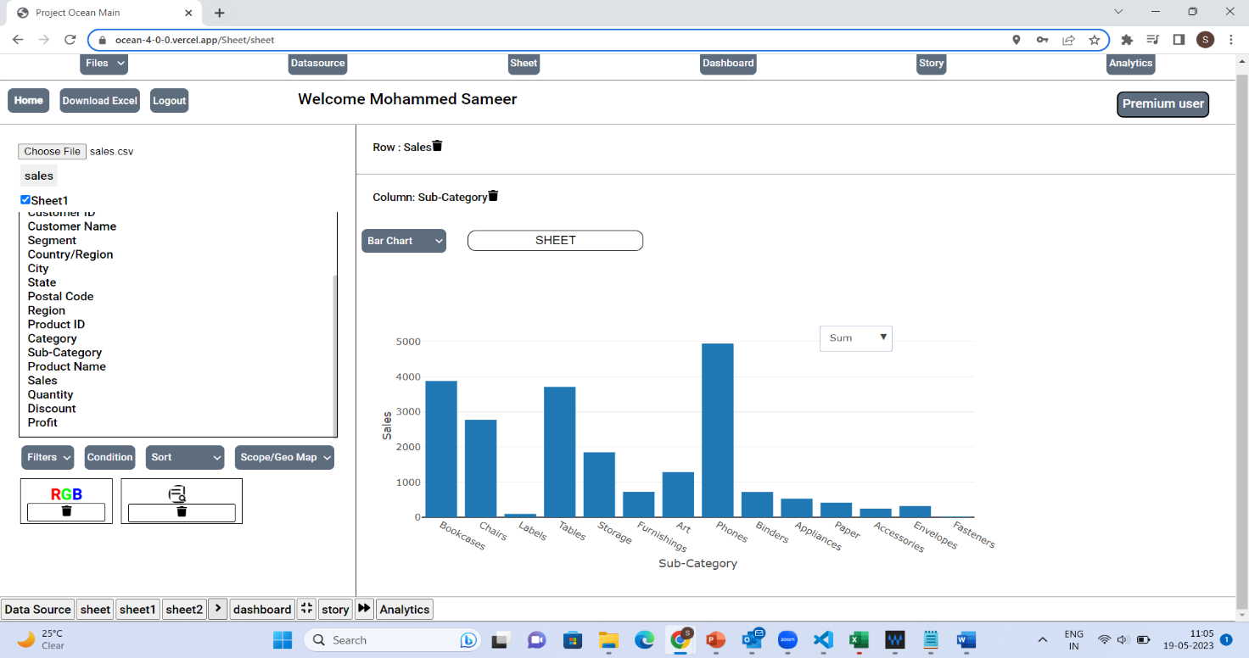

User can create multiple sheets using the button marked in the yellow box and plot different graphs on each sheet for clear analysation. N number of sheets can be created using this button.

STEP 3: DASHBOARD
User can create dashboard page to compare between all other sheets based on different fields.
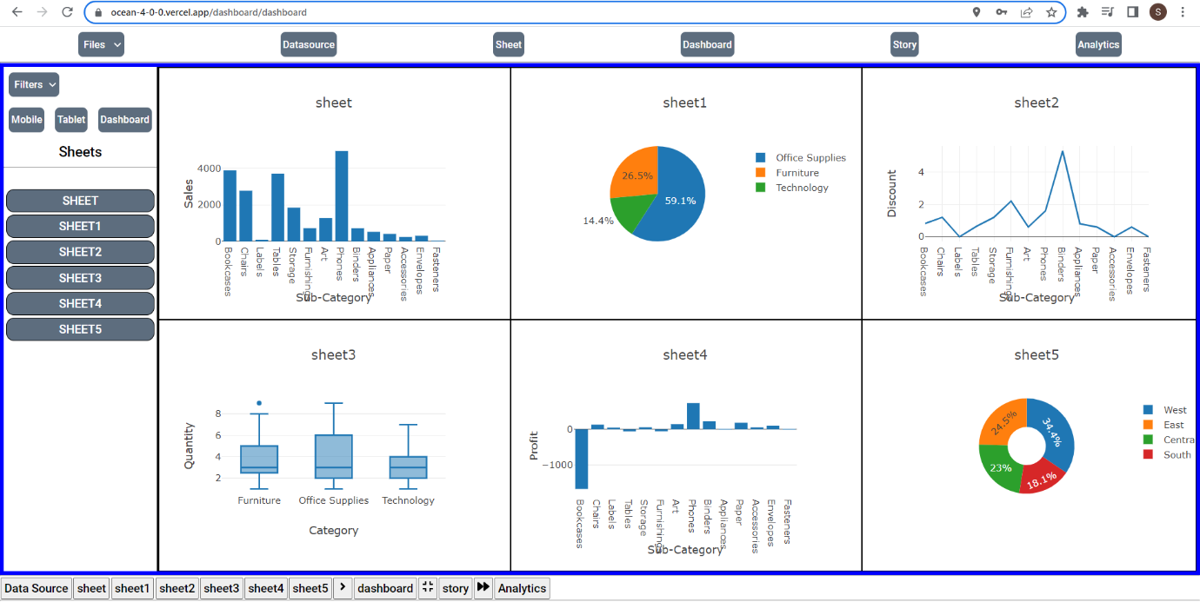
MULTIPLE DASHBOARDS
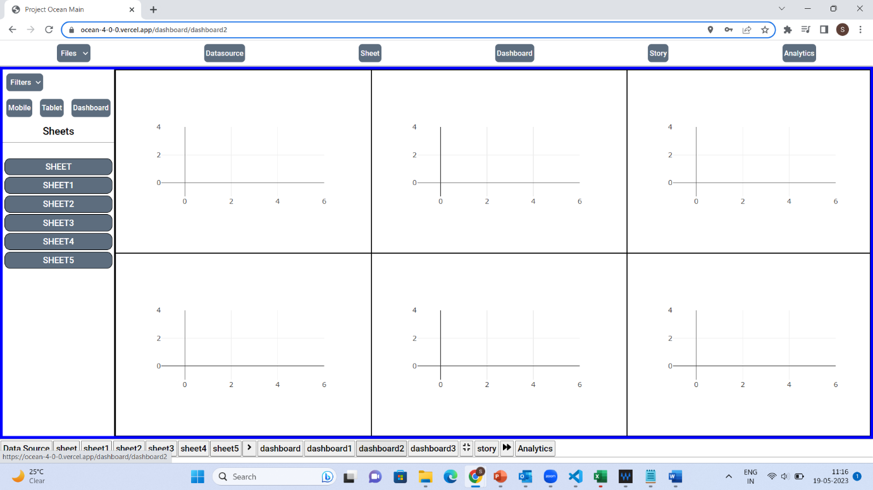
Multiple Dashboards can be created using the button highlighted above and each dashboard page contains six different sheets and user can create n number of dashboards.

RESPONSIVE VIEW OF DASHBOARD
There are three different ways that dashboard can be viewed that is
- Mobile
- Tablet
- Dashboard

MOBILE VIEW
Mobile Responsive can be viewed by selecting the mobile button in the left on the dashboard.
This is mobile responsive which contains screen size of less than 500px.
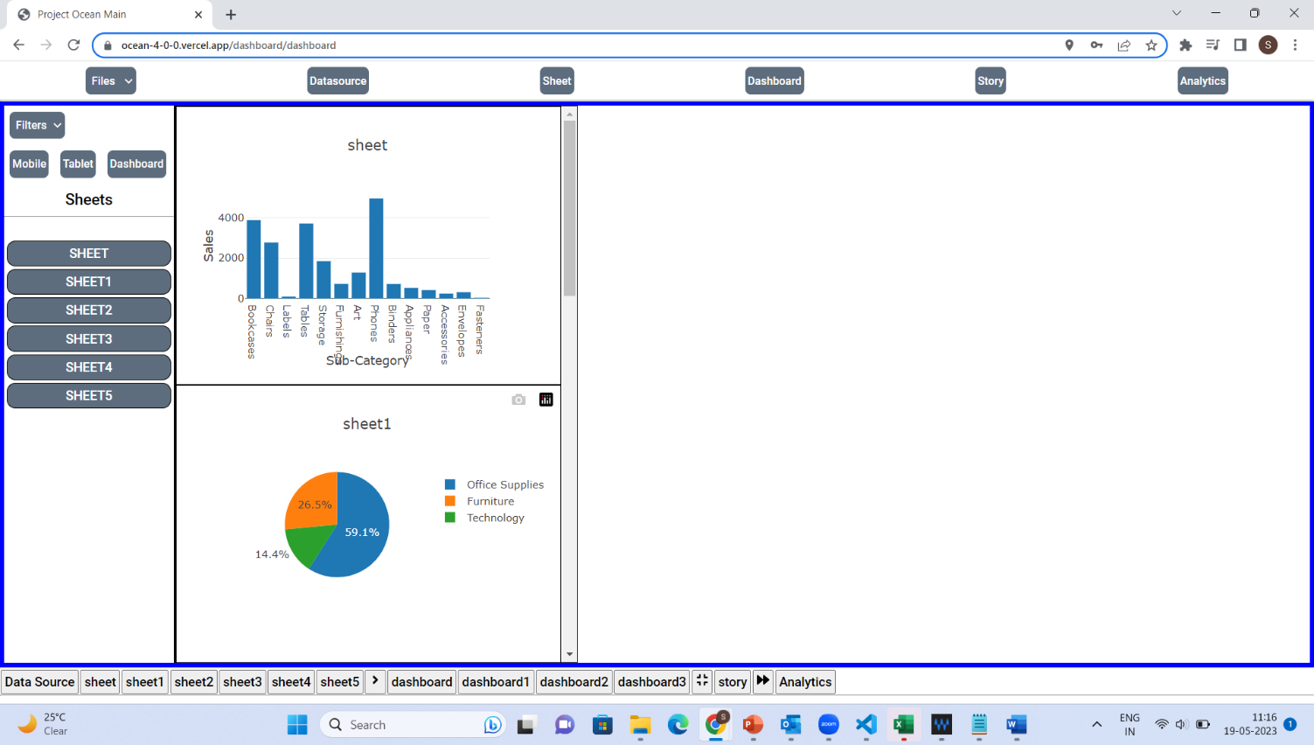

TABLET VIEW
Tablet Responsive can be viewed by selecting the tablet button on the left-hand size of the dashboard page.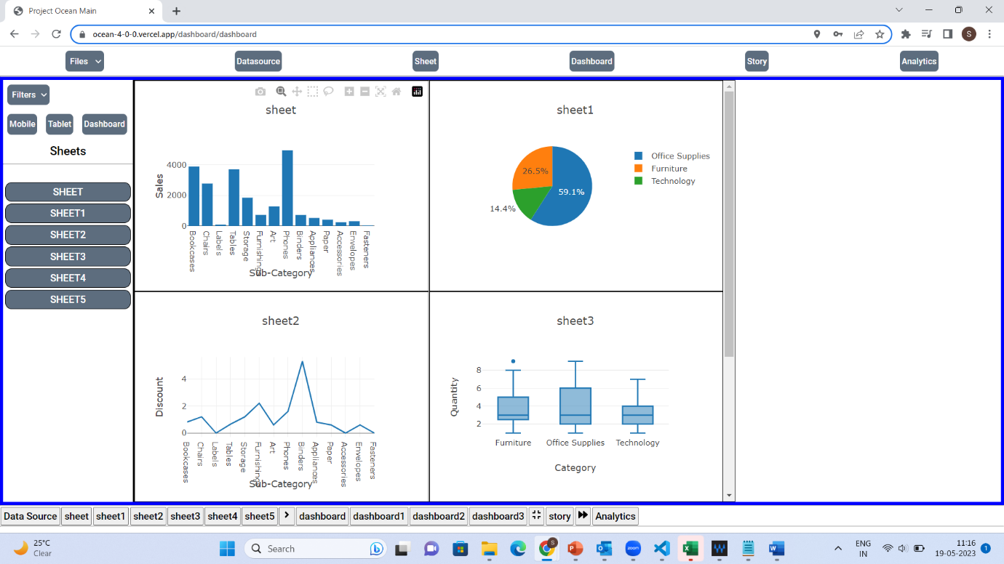
The screen size of tablet responsive view is greater than 550px and less than 800px.

DASHBOARD VIEW
Dashboard view is the normal dashboard view with 100% screen size and it is not less than 900px.
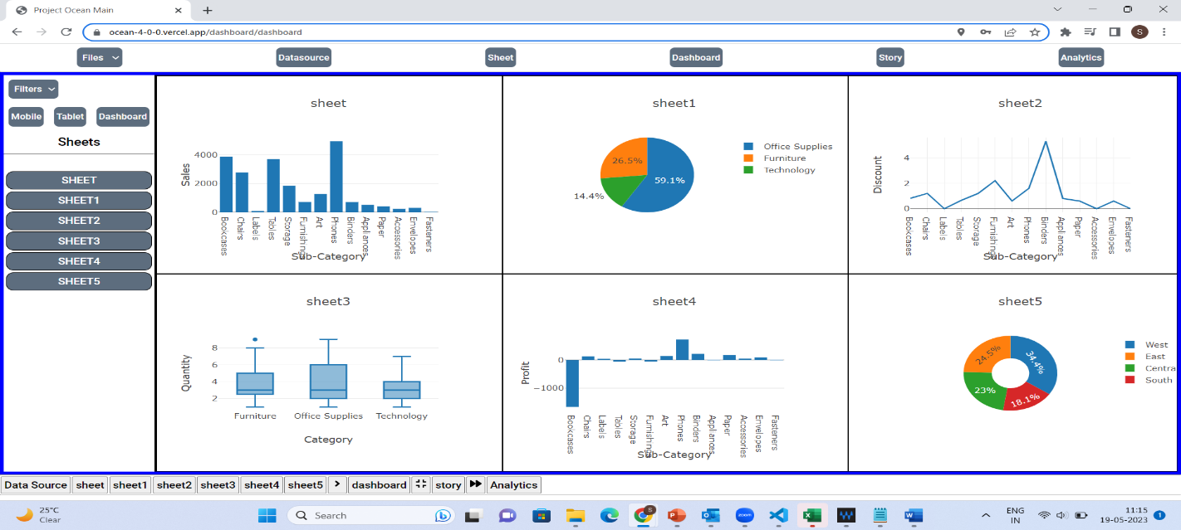
STEP 4: STORY BUILDING
Users can create stories with the dashboards and sheets. N number of sheets and dashboard can be used on single story. And also, multiple Stories can be created.
Sheet on STORY
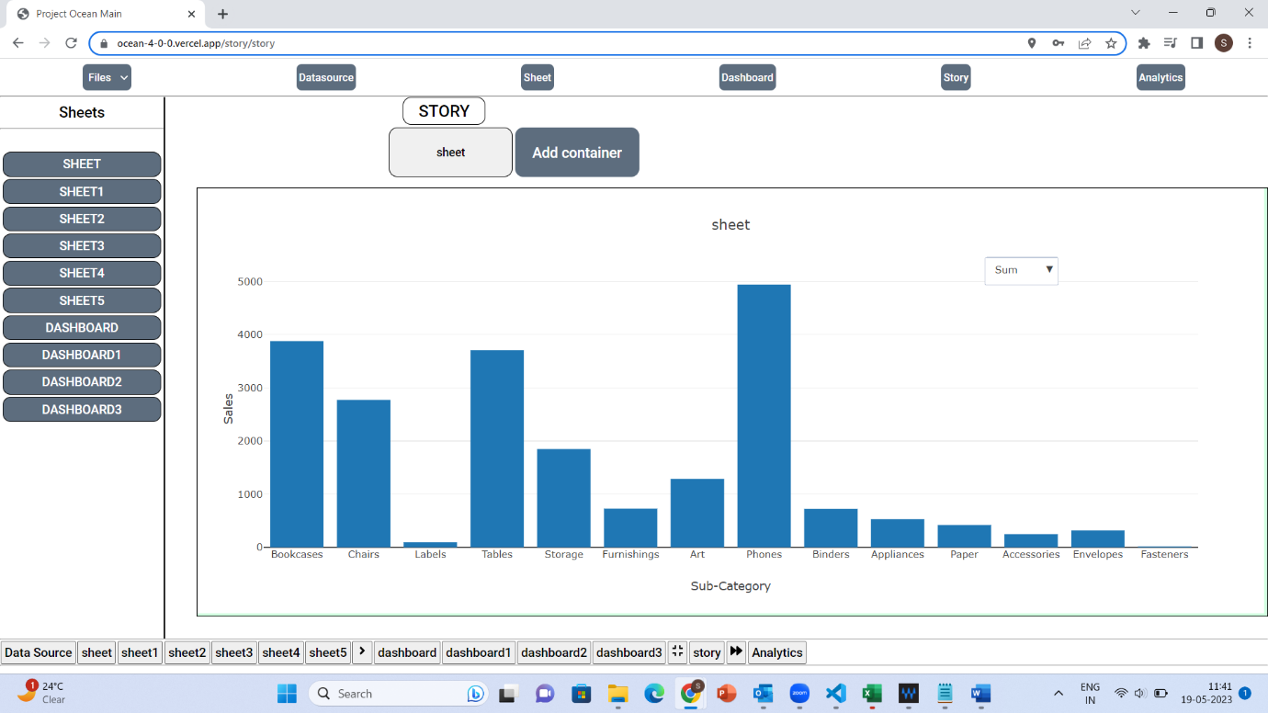

Click on ADD container and then drag and drop your sheet and click on the container to display the sheet.

Dashboard on STORY
Users can add multiple container and drop multiple sheets and dashboards and can make a single story.
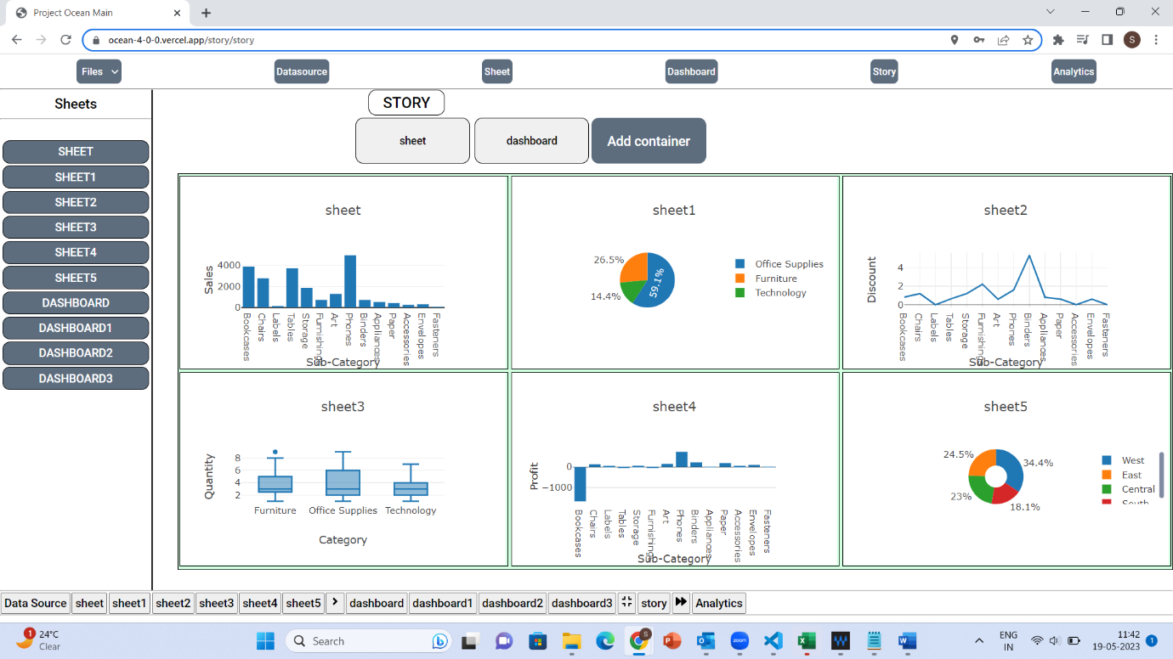

MULTIPLE STORIES

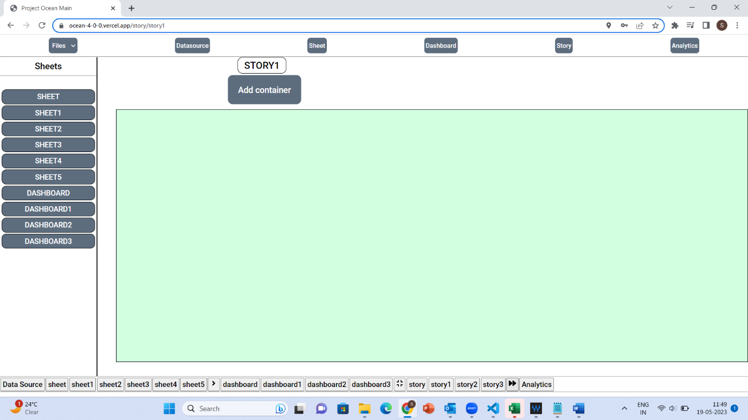
Multiple stories can be created by clicking on the button highlighted above.

