PROJECT OCEAN LINKS:
- PROJECT OCEAN MAIN: https://ocean-4-0-0.vercel.app/
- PROJECT OCEAN SERVER 1: https://python-api-productionserver.onrender.com/
- PROJECT OCEAN SERVER 2: https://python-api-wrh0.onrender.com/
- PROJECT OCEAN SERVER 3: https://ocean-user-serverbackend.onrender.com/
- Google Drive Link: https://drive.google.com/drive/folders/1gNwcq_c5jhYTWl98-WOvvdeBIZ7LYEaN?usp=share_link

NOTE: Run Servers 1, 2 ,3 as shown below to have smooth experience.
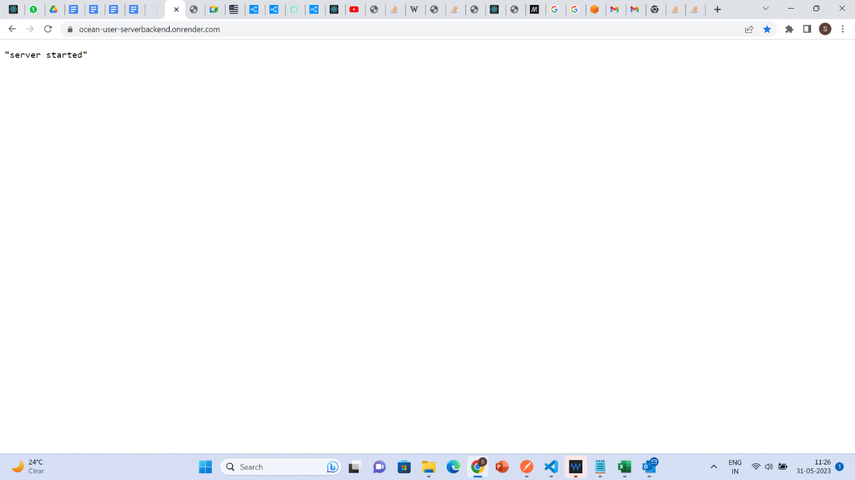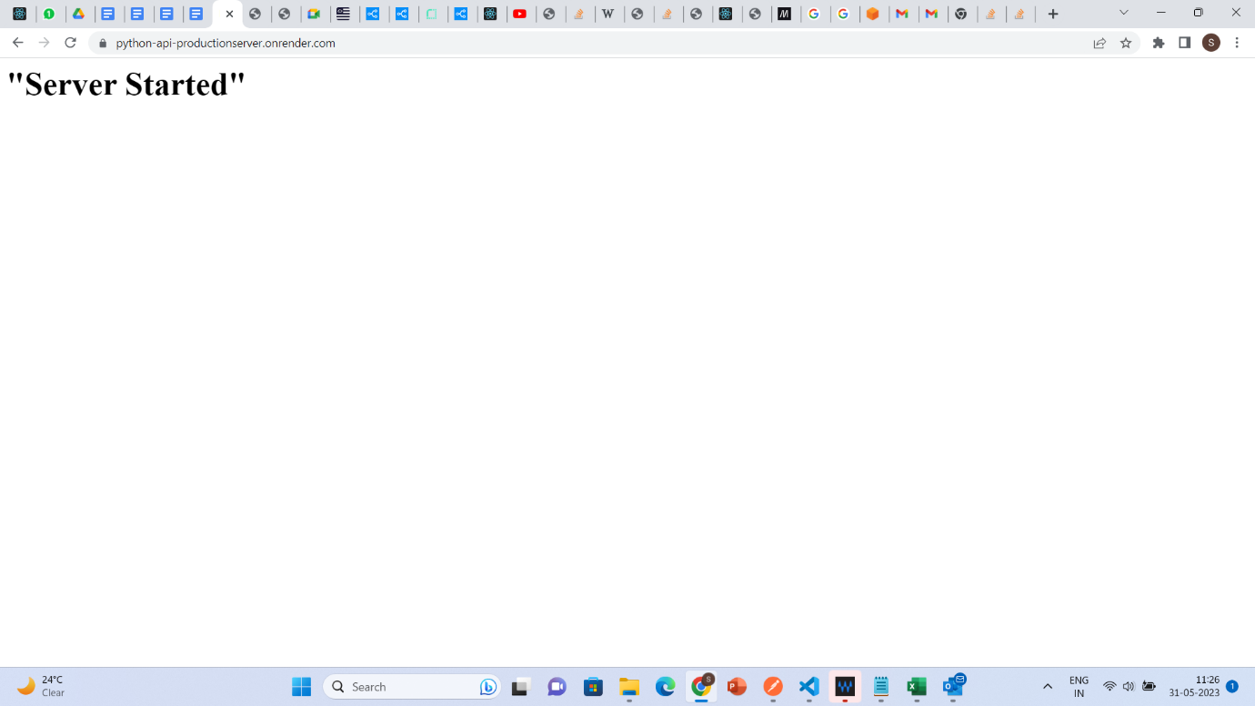

As Marked in yellow, You just need to start these servers (refresh) until same output is shown. The page should not be in Loading stage this confirms that the Servers are Running.

STEP 1: DATA INGESTION & VISUALIZATION
- Register Yourself by providing name, email and Password.
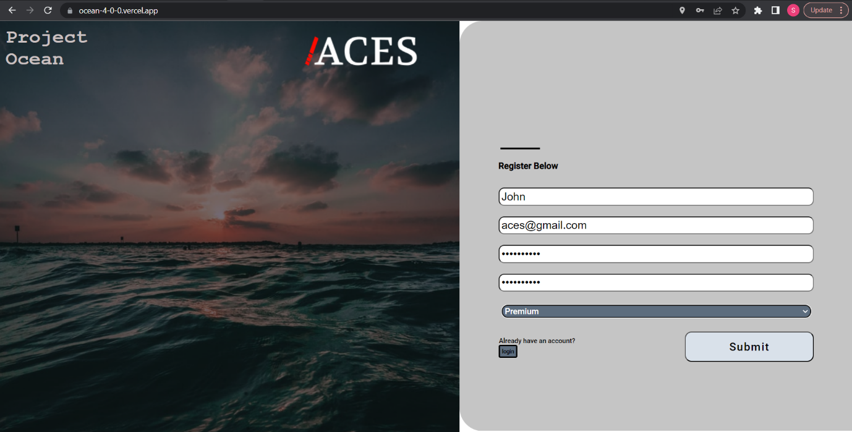

- After Clicking submit, click on the login button and login with your credentials.
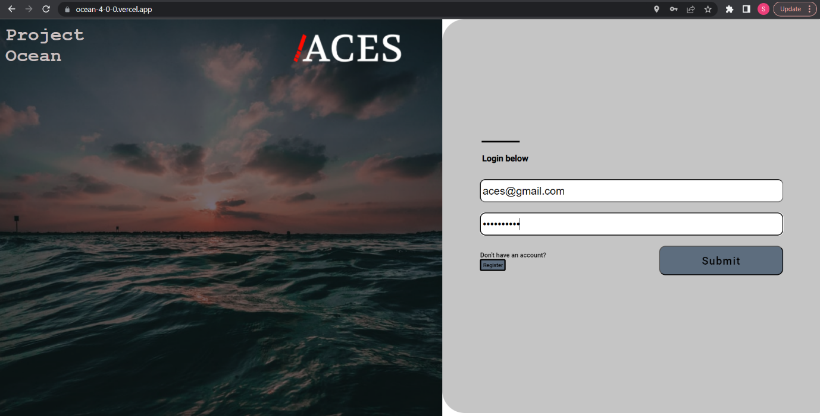

- Now you are Redirected to the Sheet page, where you can chooses any file and upload.
(Note: The File inputs are Xlsx , CSV and OWBX for now, and File limitation is 5MB)

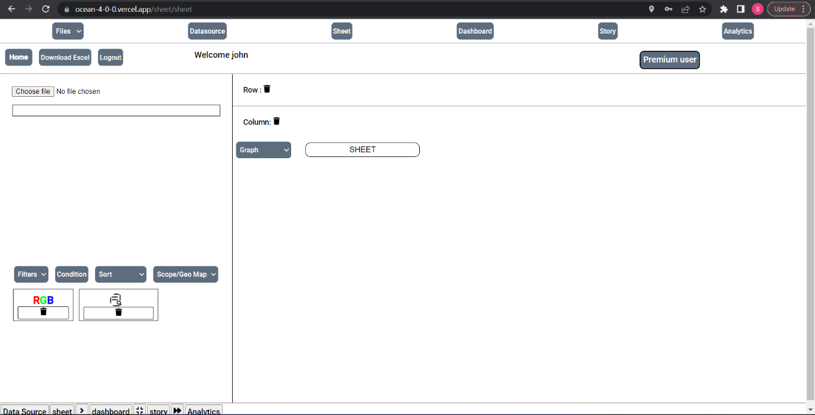
- Now as provided in the Google Drive link, we are working with Sales.csv/Sales.xlsx Dataset.
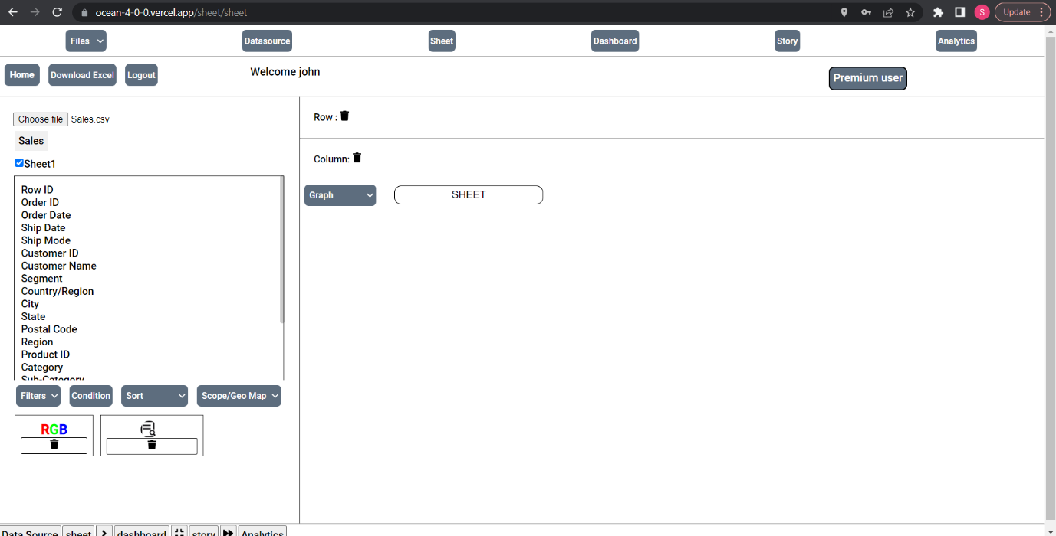
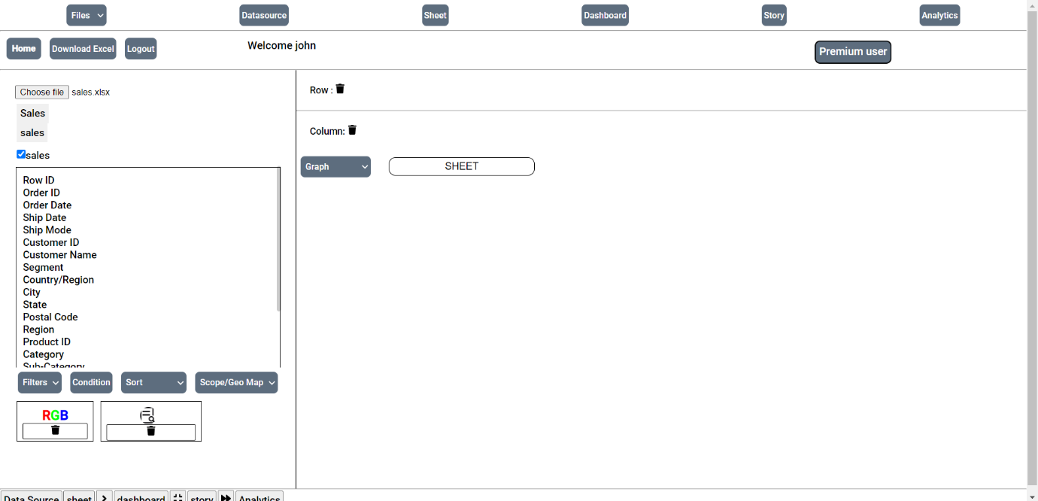
- You can Navigate to Datasource Page to check the whole file similar to that of Excel Sheet.
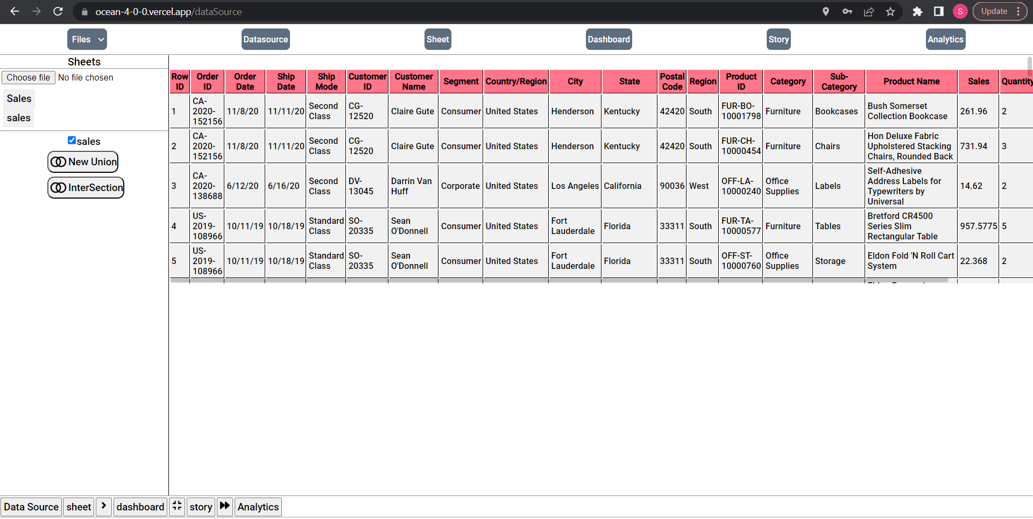

- Navigate back to sheet page, Now Drag and Drop any two of the headers in the Row and column section and select any graph.
(Note: Column takes numerical and Row takes categorical)
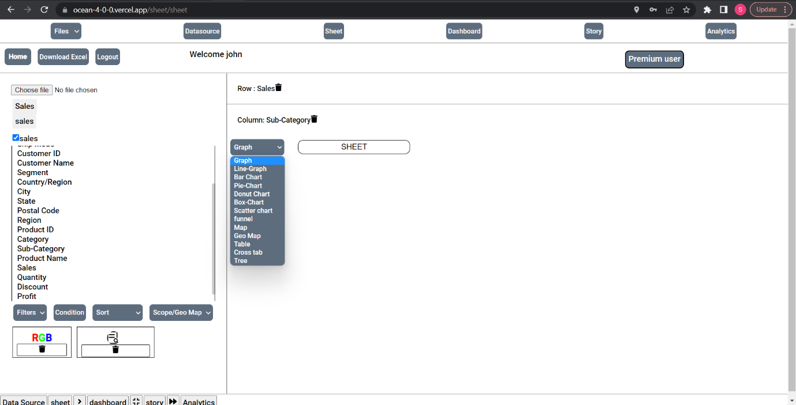
- Here are few representations of given charts.
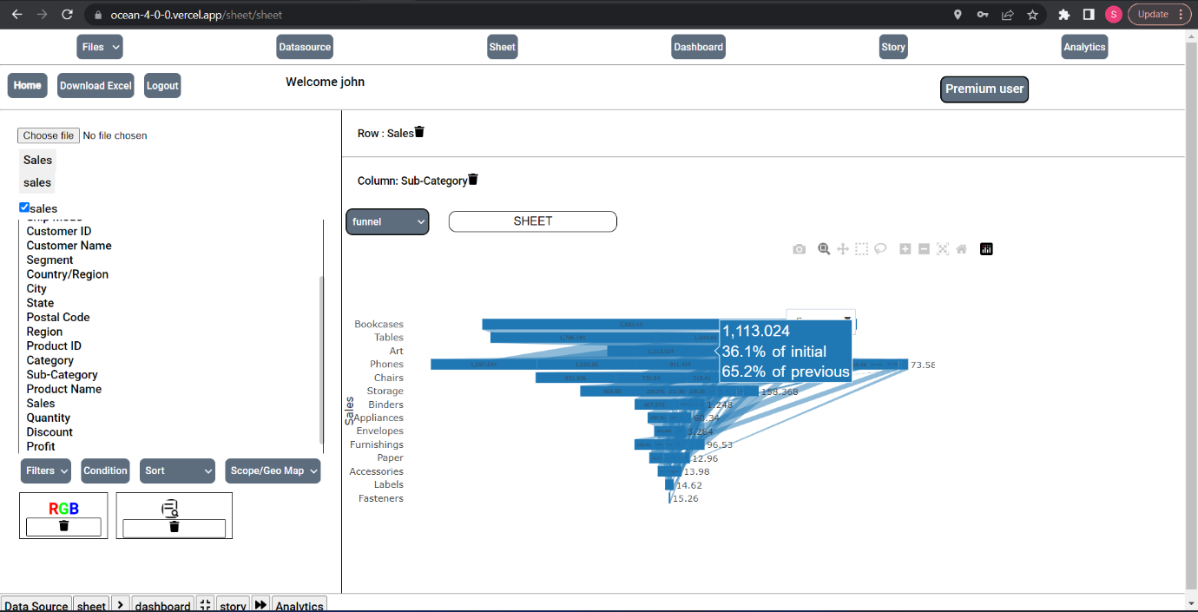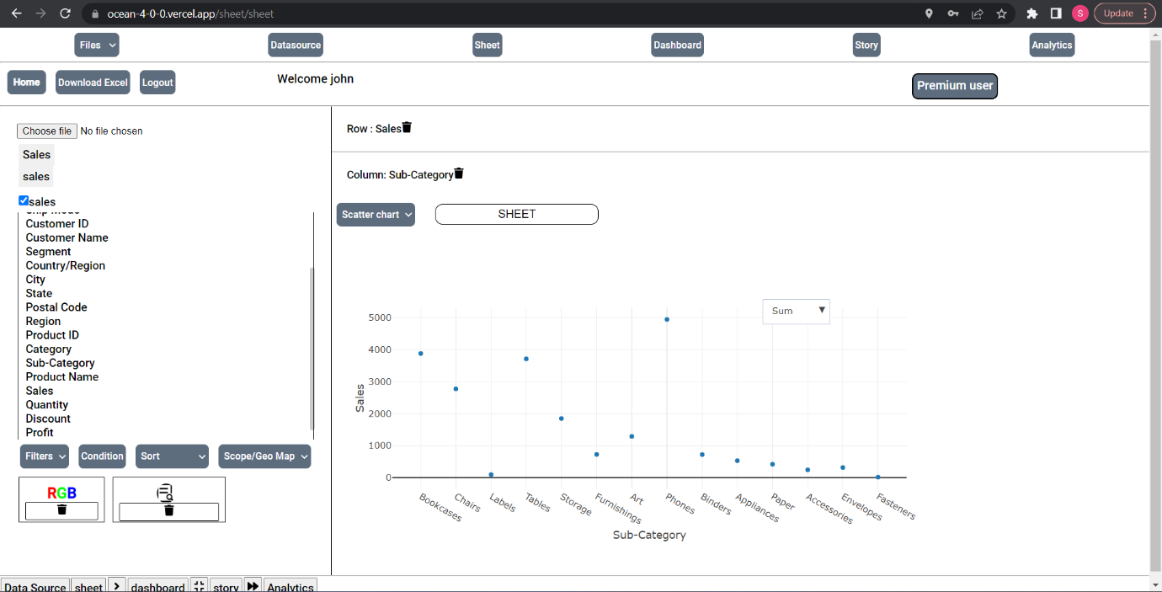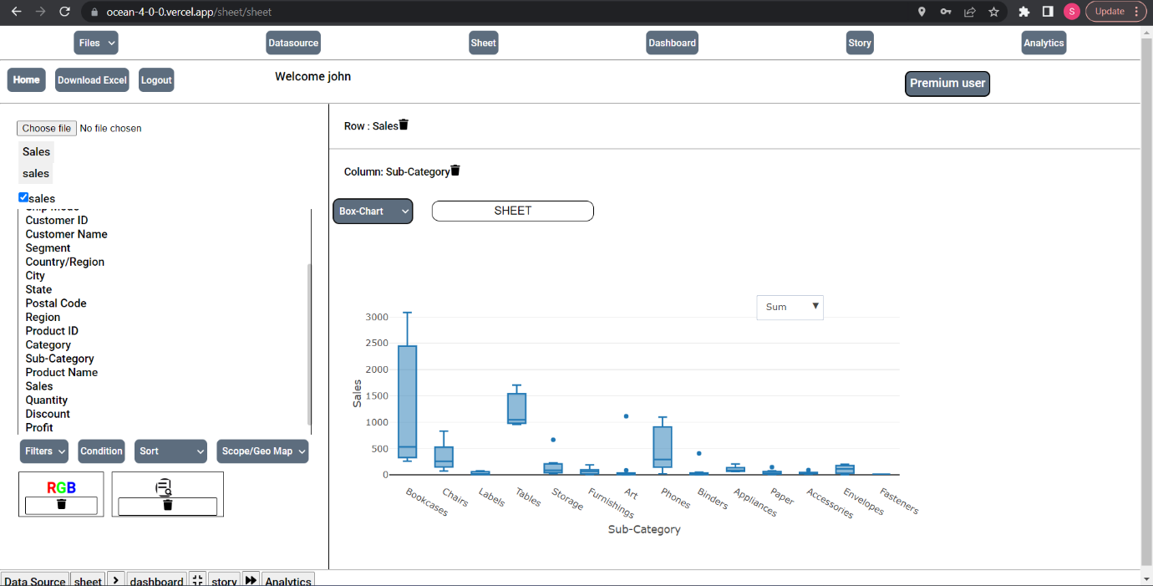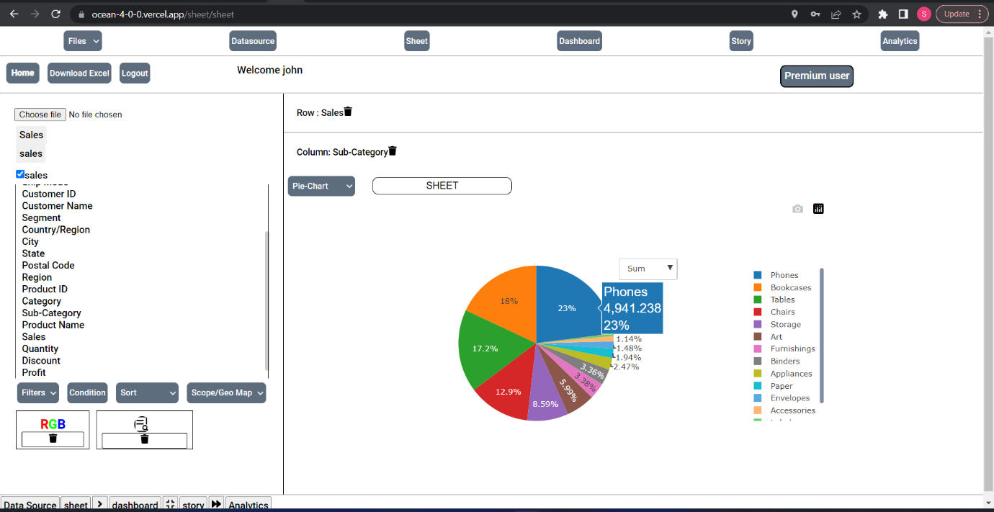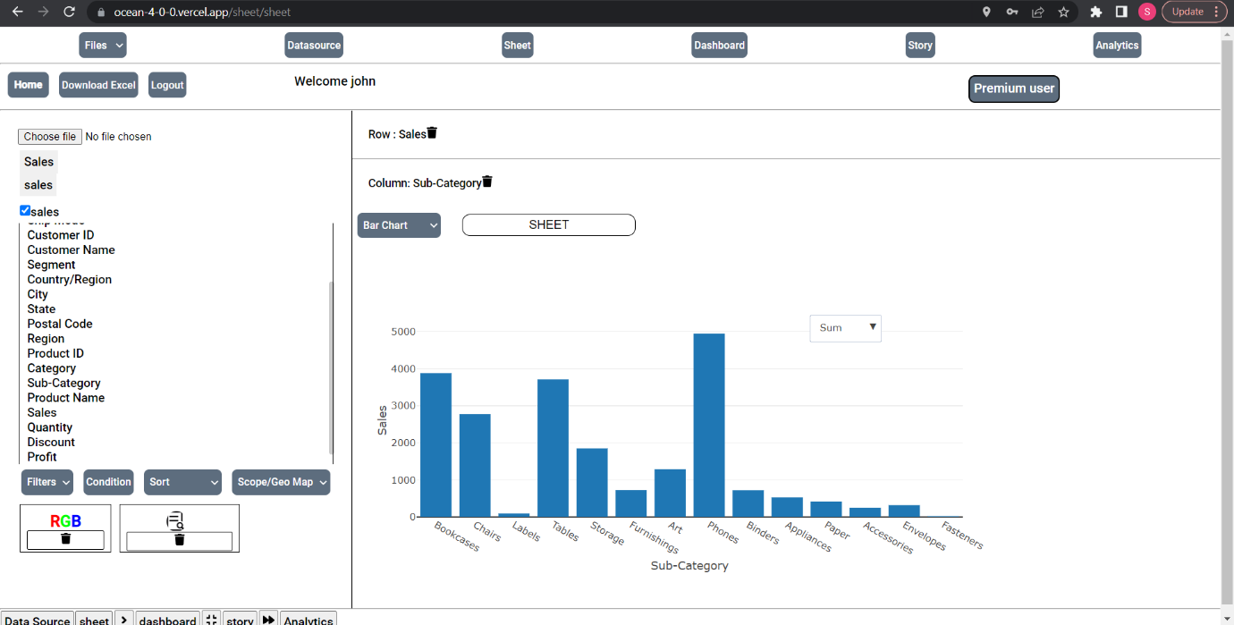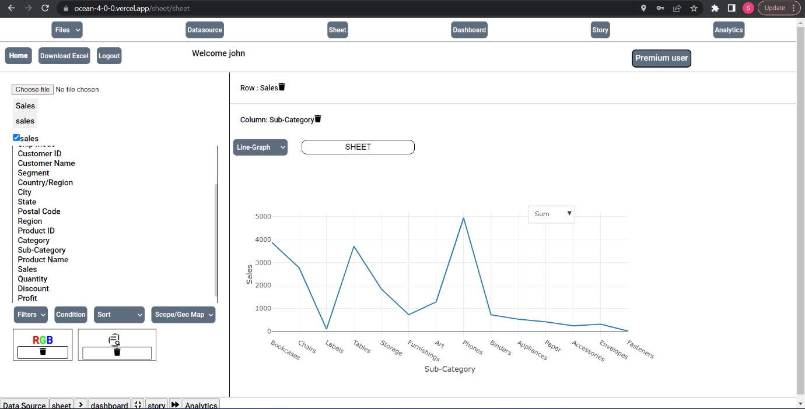
- Now you can upload another file from google drive with latitudes and longitudes.
(Note: Row takes Latitude and Column takes Longitude) and select map or geo map to display the dots. In case, the map does not render or change switch to another graph and switch back to map. As shown , You can click and toggle between uploaded files for different sheets.

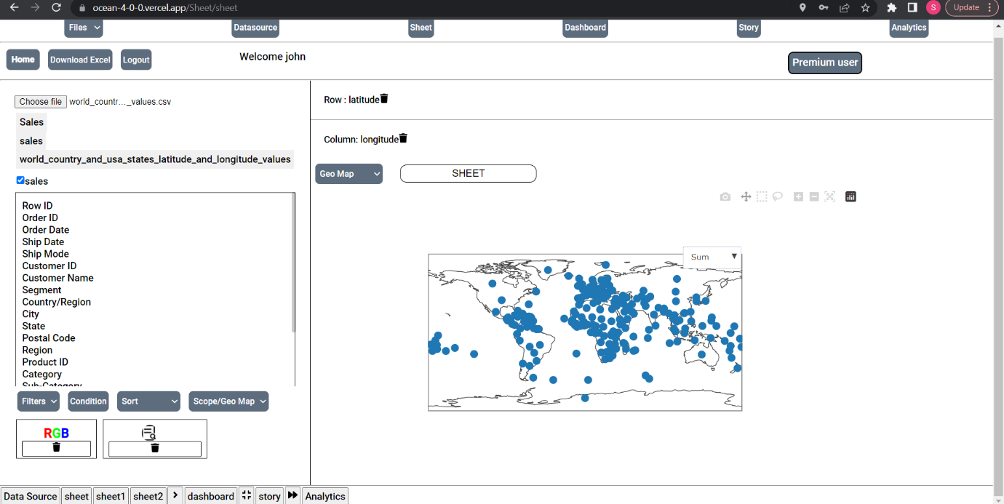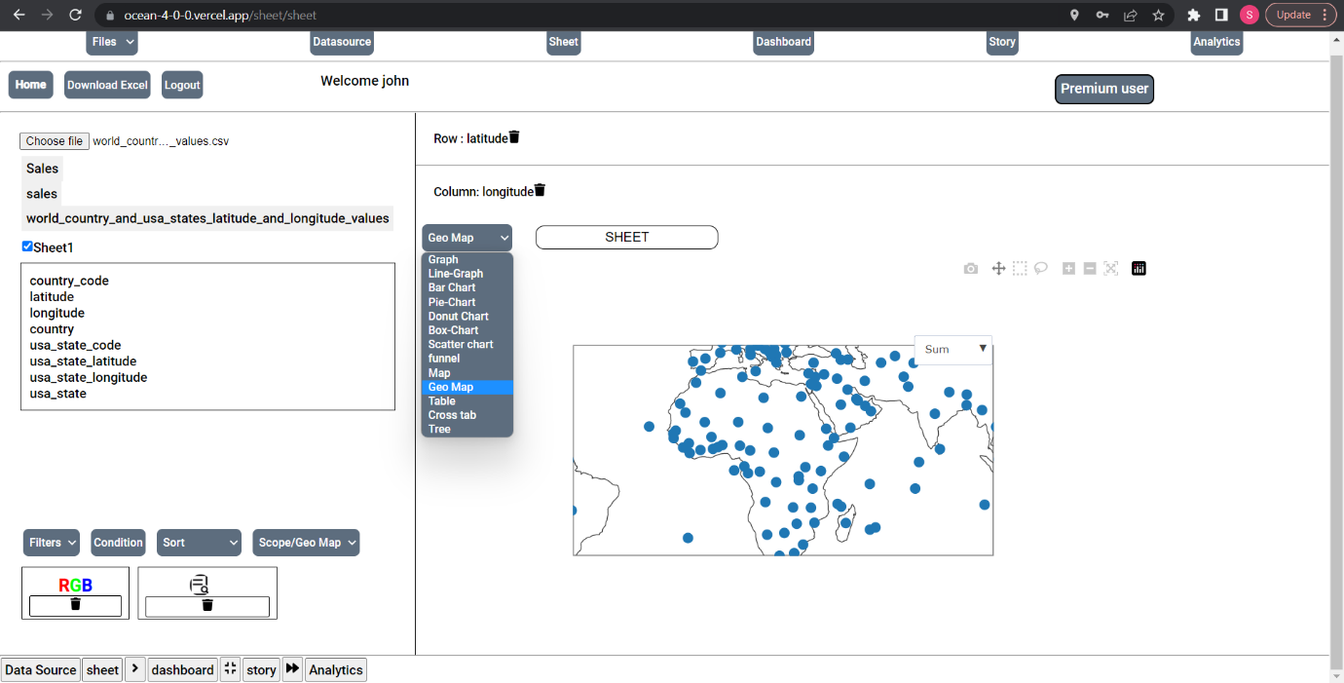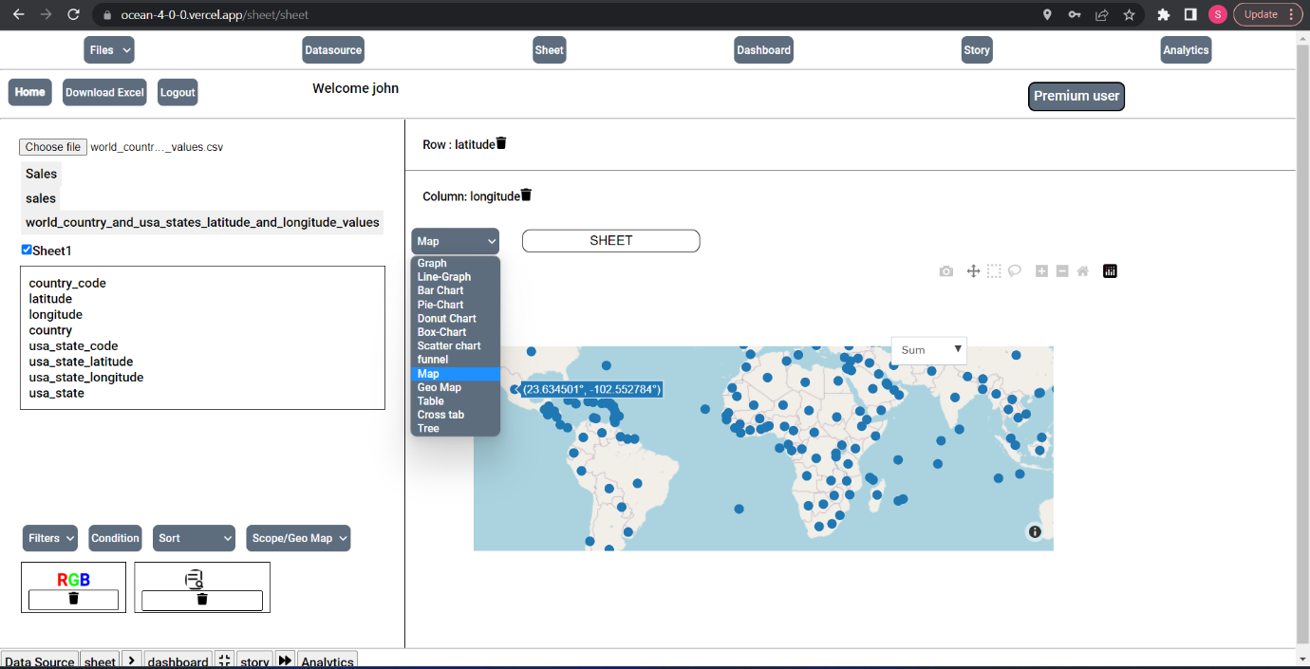

- To increase more level of detail we are using the RGD function (Works well on Bar chart) As shown in the picture. You can press on marked button to add new sheet.
You can also Drop any 3rd category on RGB to display more level of detail, You also toggle the colors and get more level of detail.
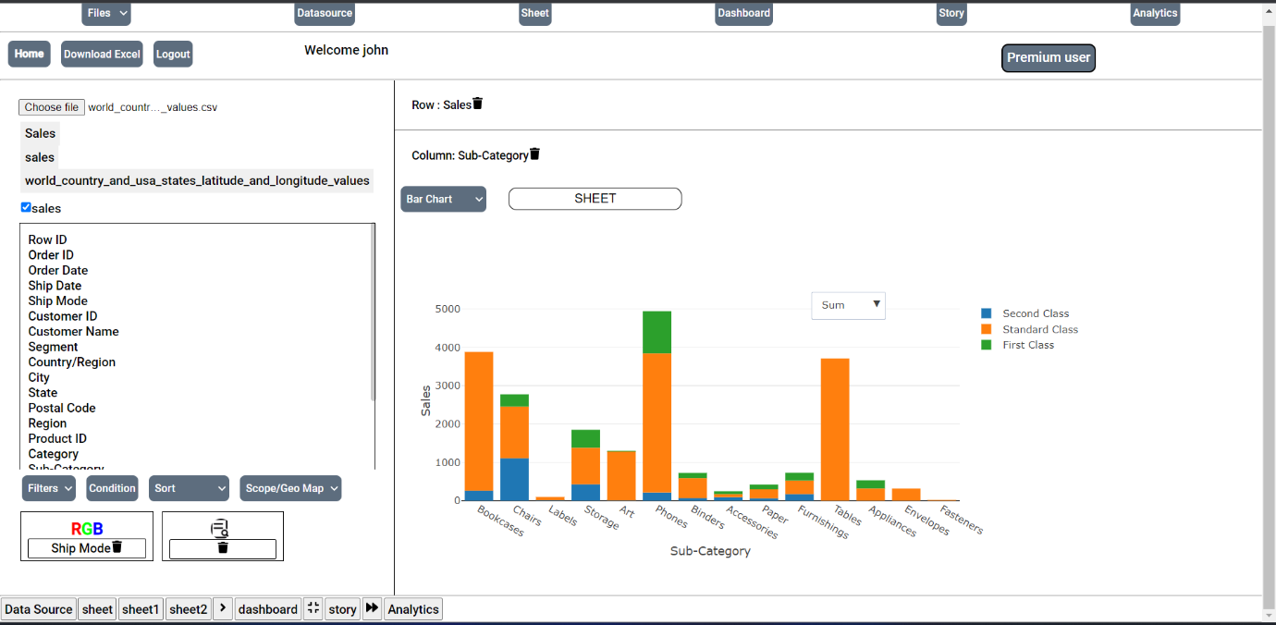

- In the below example, we are in a new sheet and dropped new values in Row, Column and RGB to display the Bar chart with more detailed info. You can hover over the bars to display the correct values.
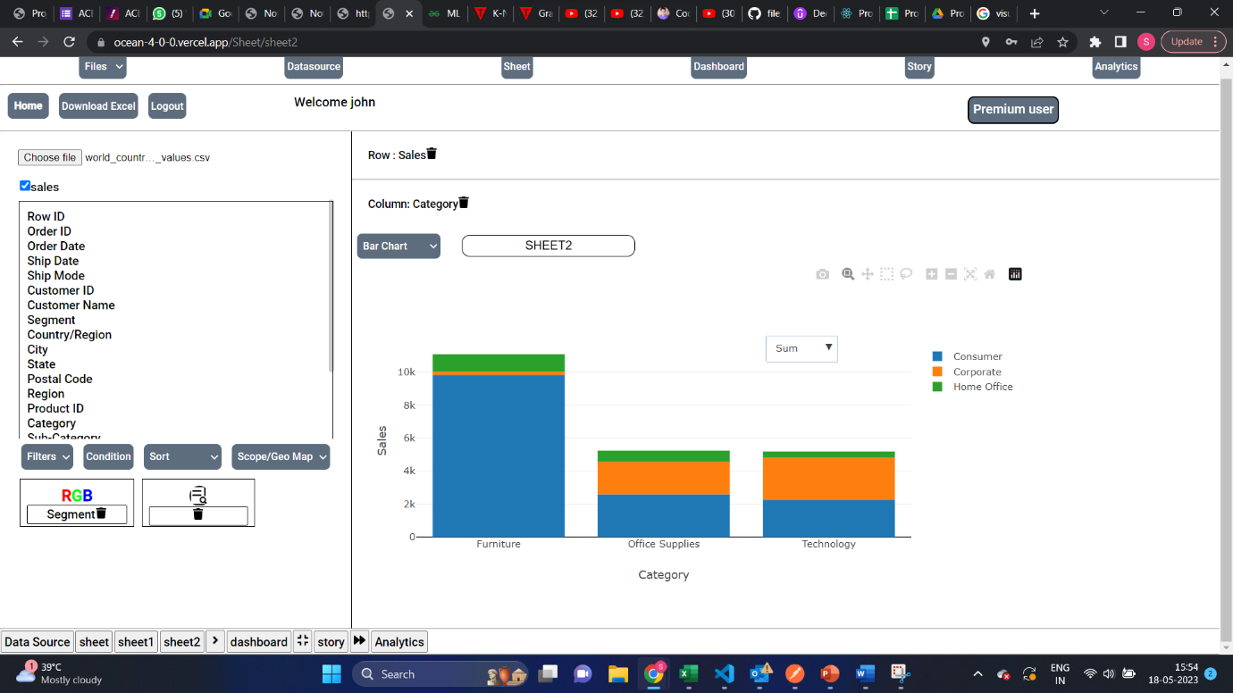
- You also use aggregation function like sum, avg etc to have more in-depth view of the chart.
