PROJECT OCEAN LINKS:
- PROJECT OCEAN MAIN: https://ocean-4-0-0.vercel.app/
- PROJECT OCEAN SERVER 1: https://python-api-productionserver.onrender.com/
- PROJECT OCEAN SERVER 2: https://python-api-wrh0.onrender.com/
- PROJECT OCEAN SERVER 3: https://ocean-user-serverbackend.onrender.com/
- Google Drive Link: https://drive.google.com/drive/folders/1gNwcq_c5jhYTWl98-WOvvdeBIZ7LYEaN?usp=share_link

Note: Make sure the above servers are running as shown in Project ocean testing guide 1.
STEP 3: CONDITIONS AND TABLE CALCULATION
- Upload any CSV or excel file.
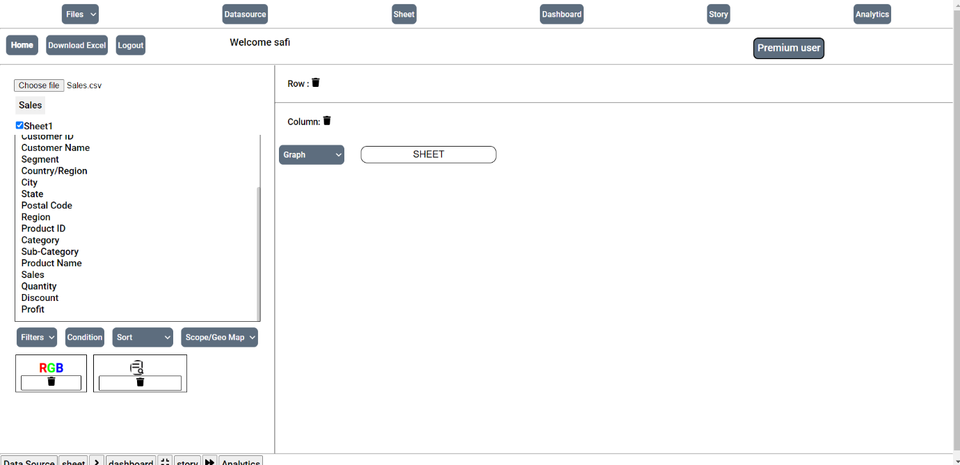
- Filters: You can use this to filter bar chart based on numerical values.
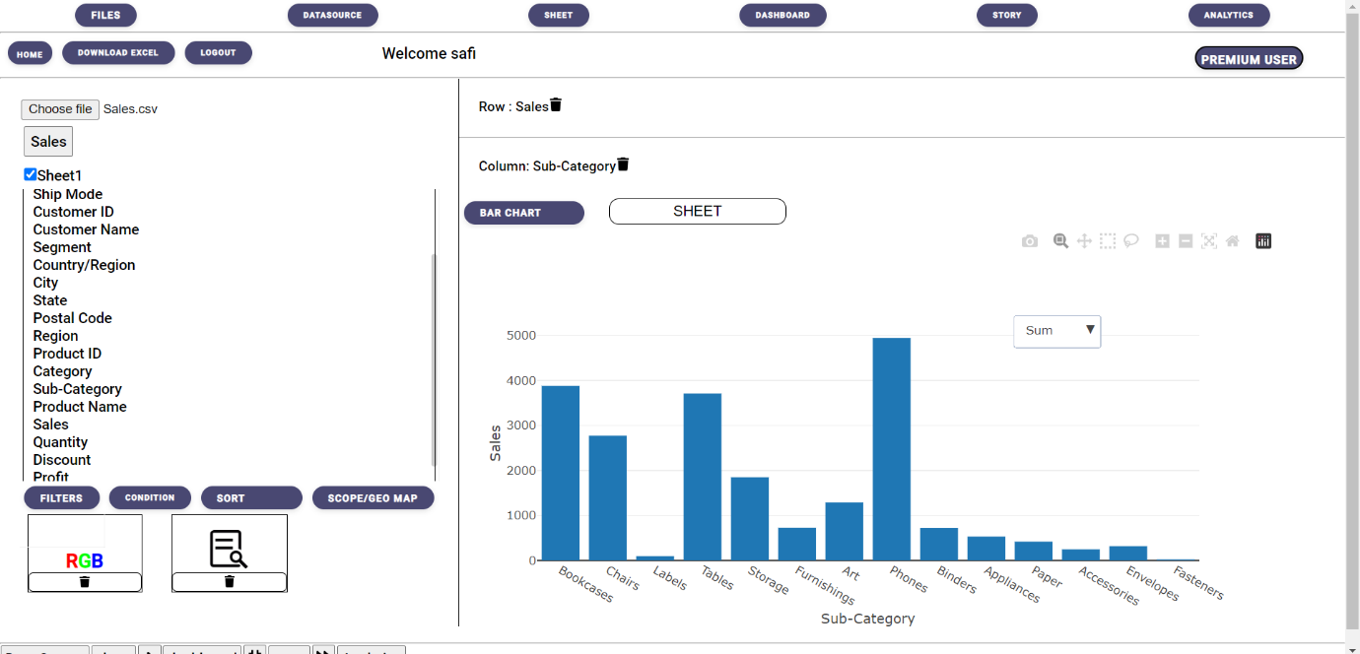
- Drop any Values in Row and Column (Row= numerical & Column = Categorical) then plot a Bar Chart. Select filters a modal-box should pop up.
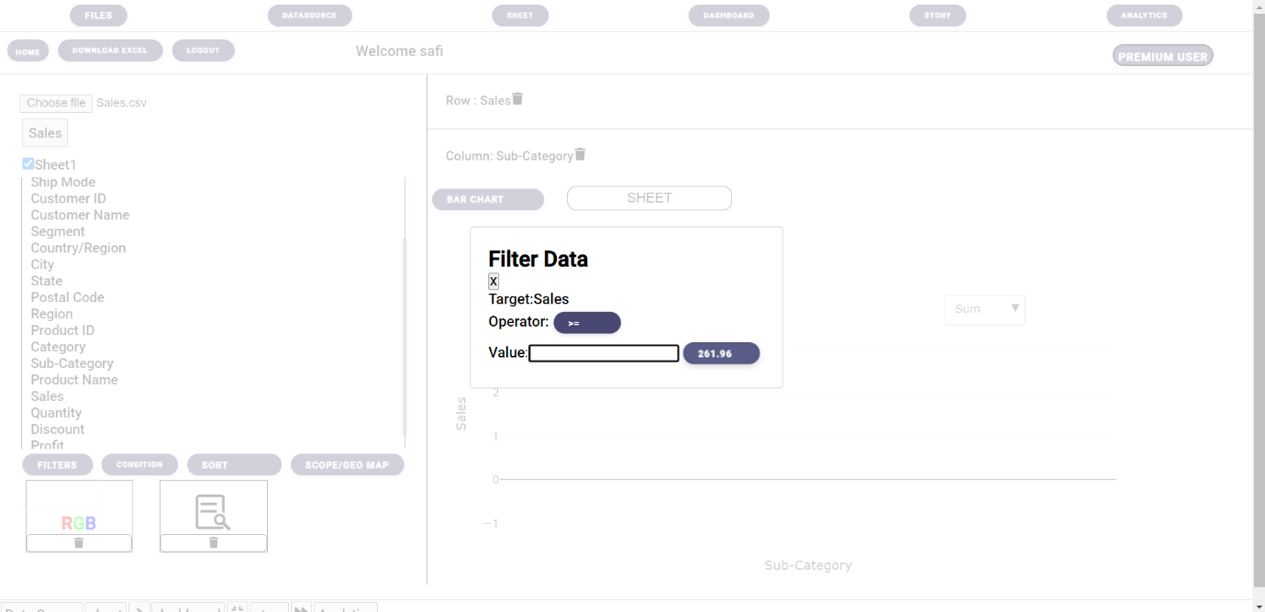
- Select any operator from given options and enter any value in value input. 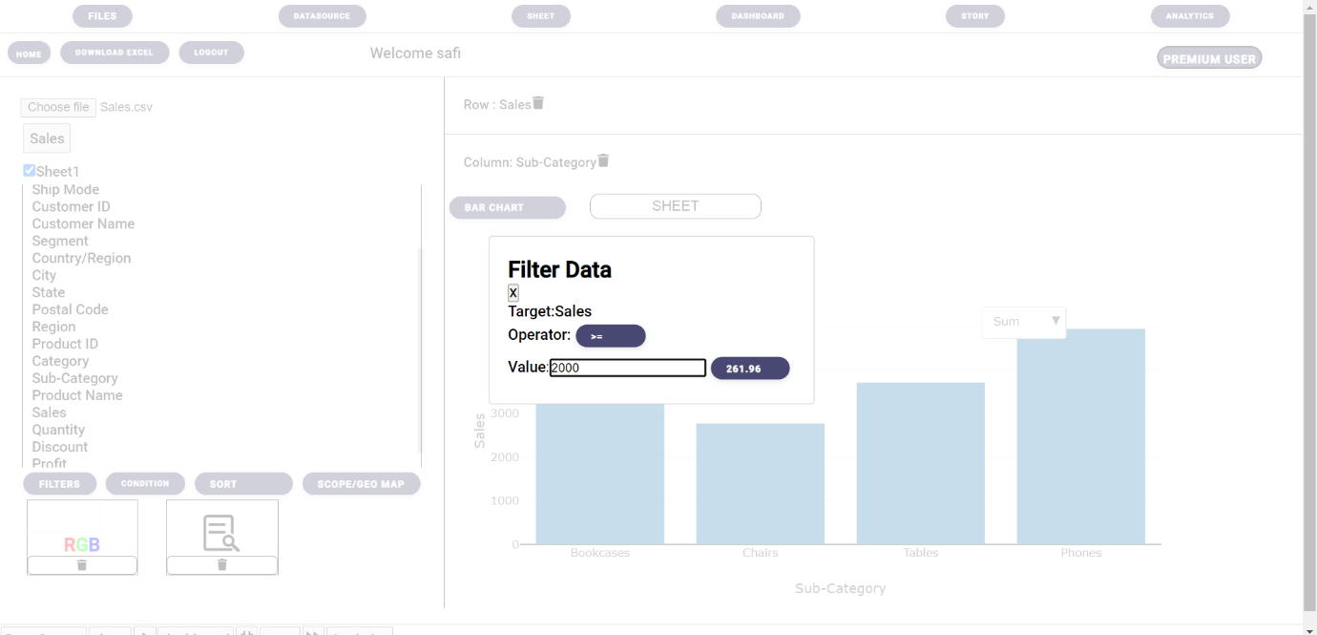
- You should be able to see the bar Chart changing behind, Close the modal box and you will se a filtered Bar chart.
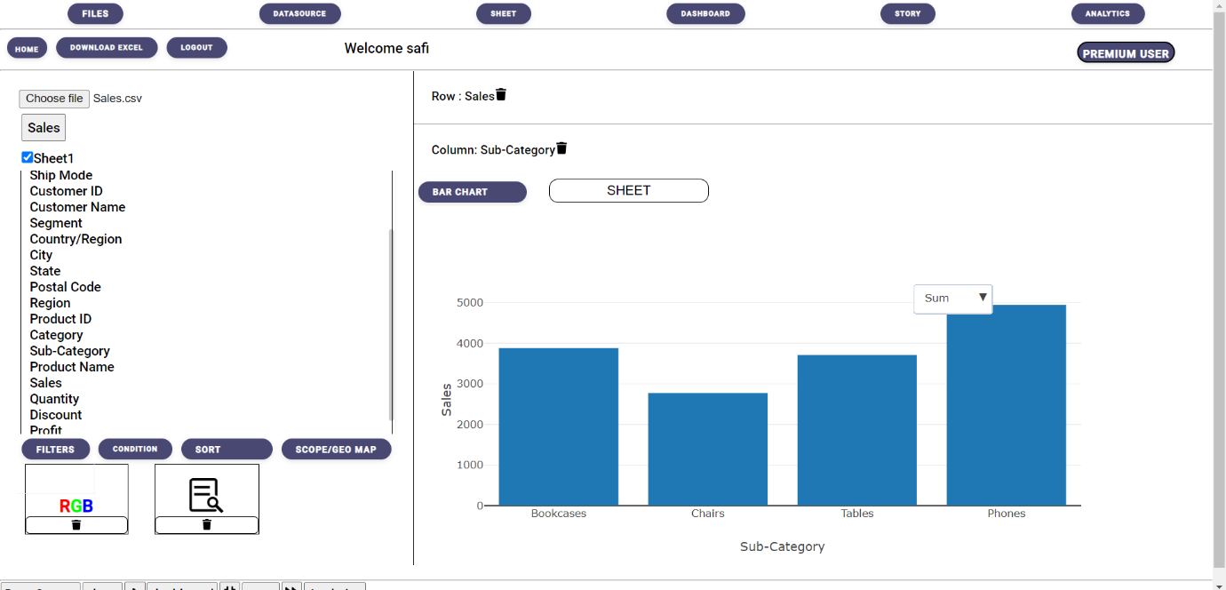

STEP 2: CONDITIONS:
- You can select Conditions beside Filters. There multiple conditions which help in gaining deeper understand of the dataset.
- A modal-box should pop-up with multiple conditions as shown below, you can select any of the given conditions and UI changes accordingly.
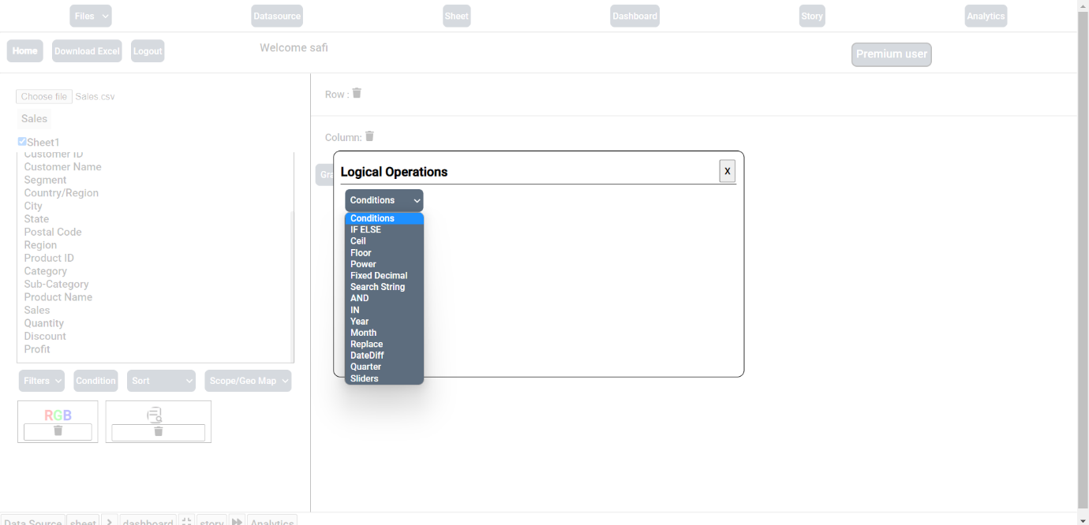
- IF-ELSE: in this condition, We first name the column header as shown we are naming it “Sales>200” next we can choose any numerical Column from the dataset.
We are checking “If Sales >= 200 we want it to say either TRUE or FALSE” or anything for your understanding.
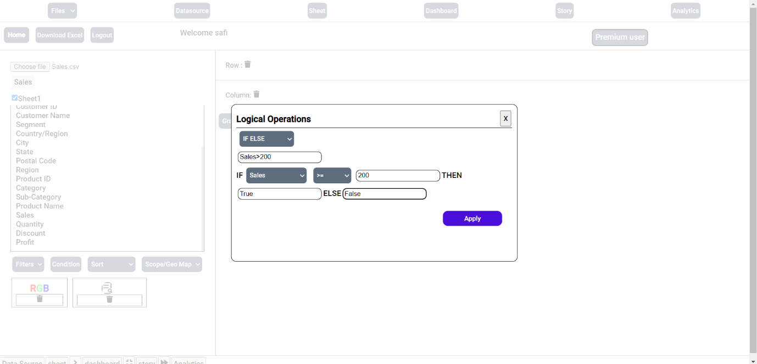
- Next navigate to Data source page and at the end of the Dataset we can see a new column called “Sales>200” with TRUE or FALSE values.
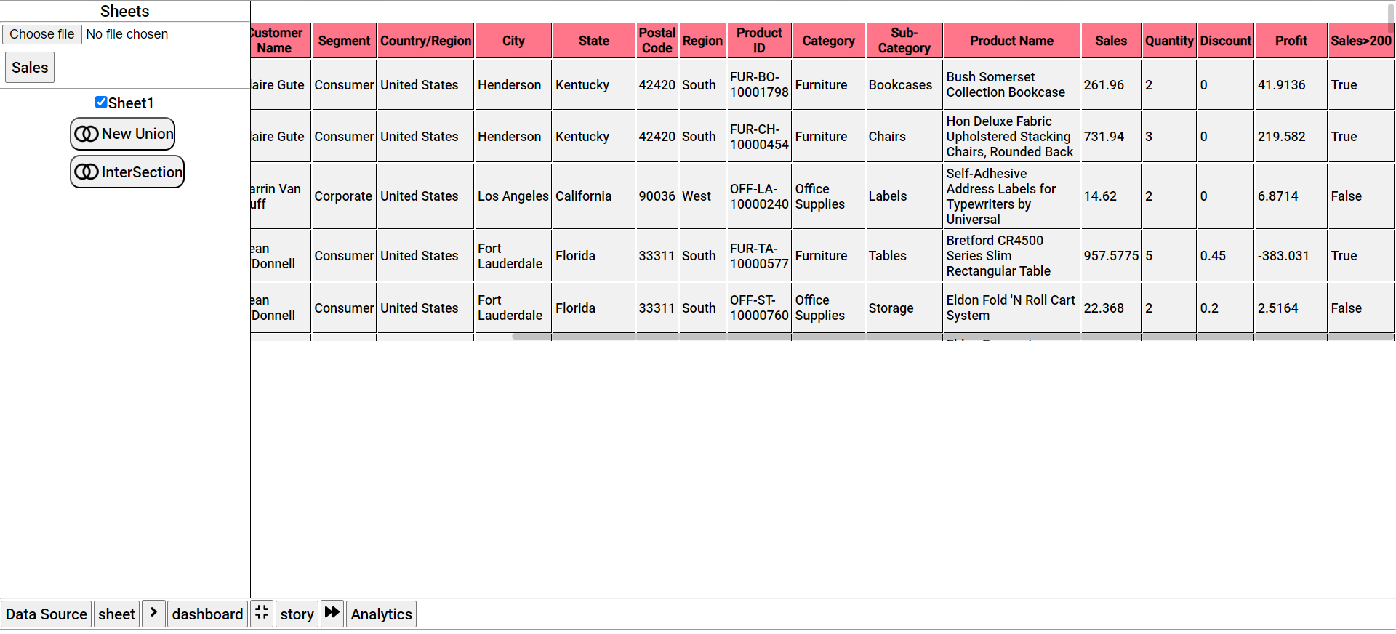
- Next Condition is Ceil: Rounds up and return the smaller integer greater than or equal to a given number.
Name the Column, we are naming it “Ceil” as shown below then select any numerical column. We have chosen “profit”
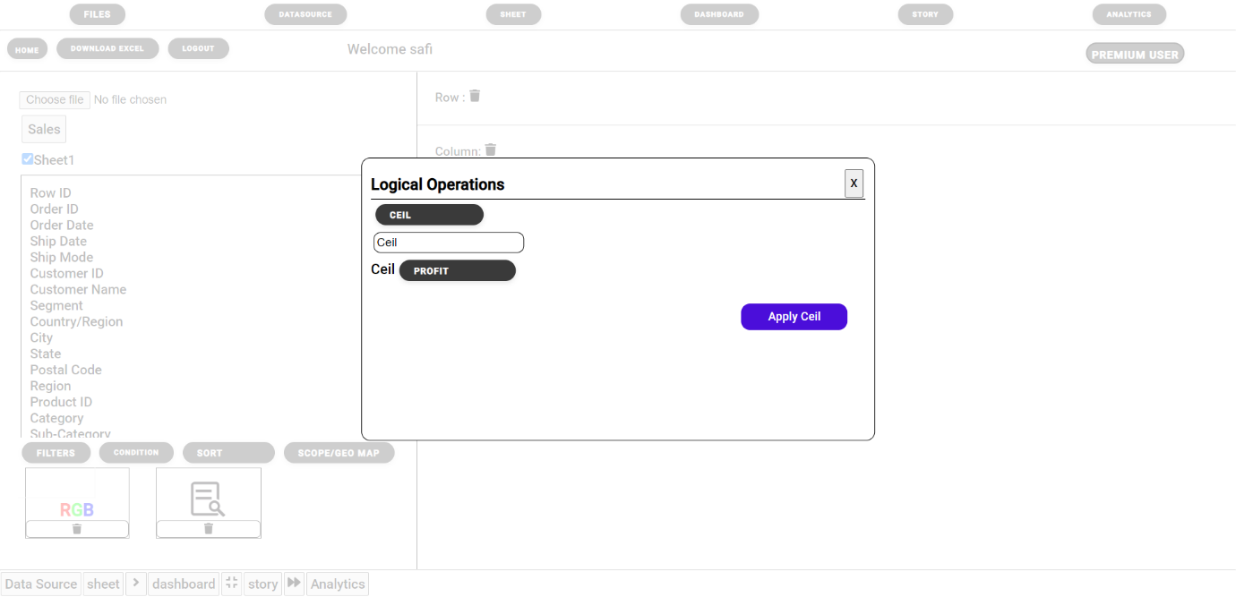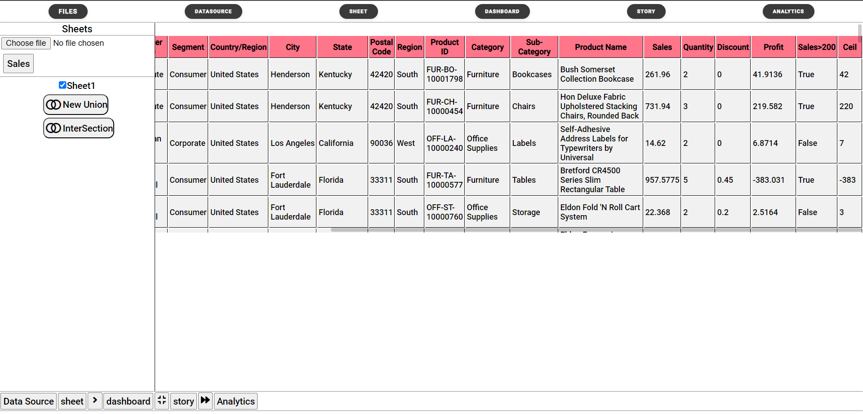
- Floor Condition: Always rounds down and returns the largest integer less than or equal to a given number.
- Power Condition: Returns the value of a base raised to a power.
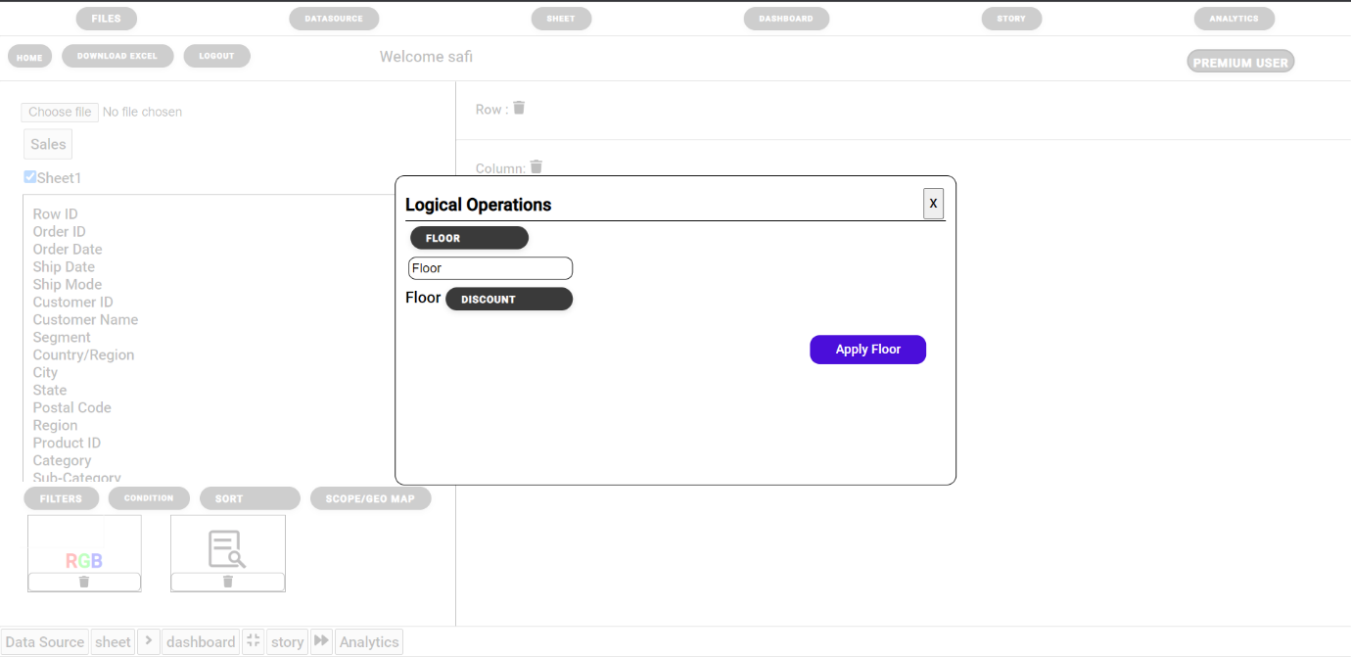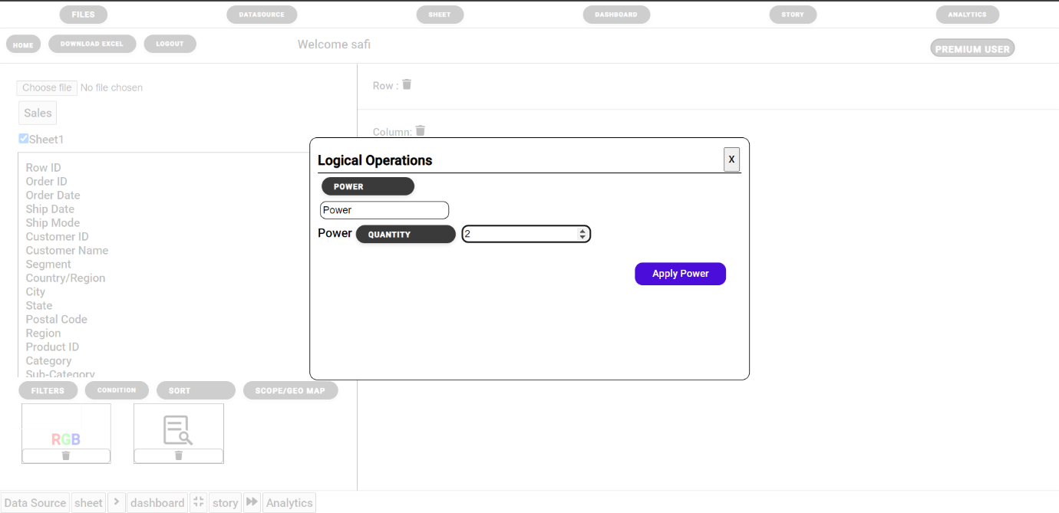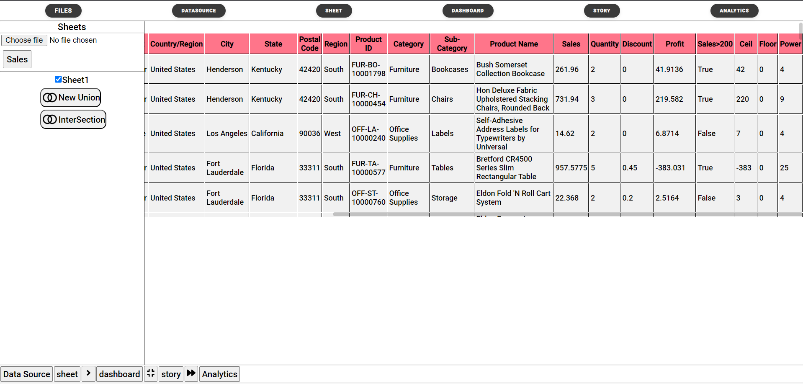
- And : And condition checks if both the condition are true then TRUE else FALSE.
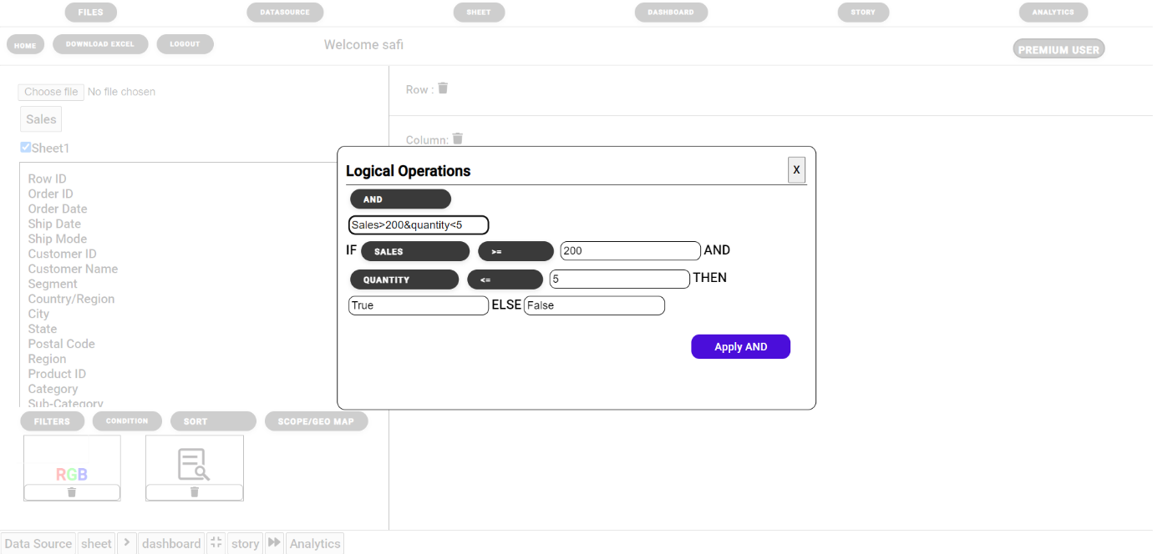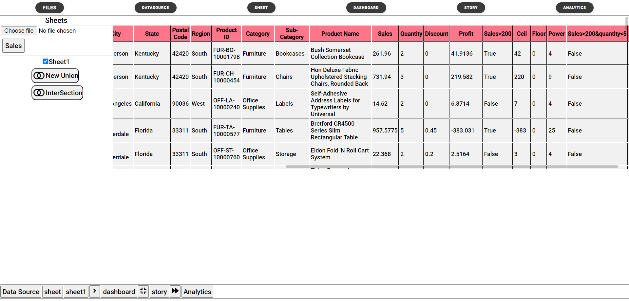
- In Condition: Checks if that value specific is inside the select Column. If yes then TRUE else FALSE.
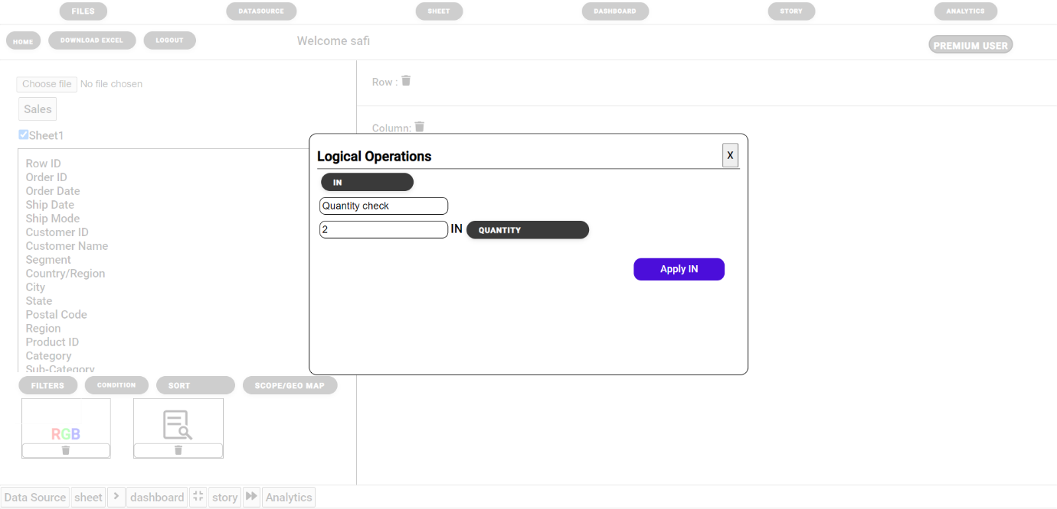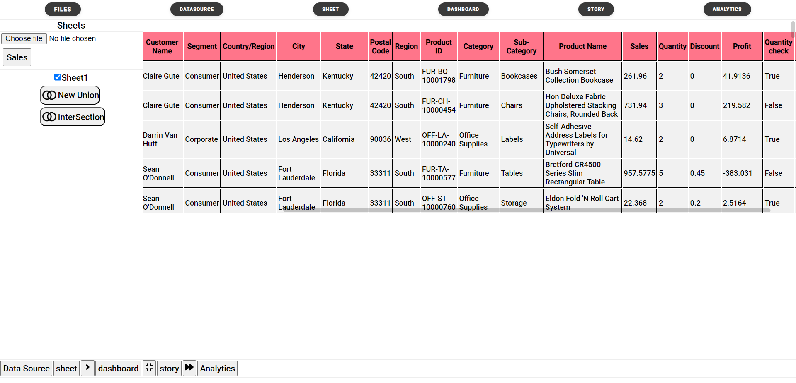
- YEAR condition: Choose any column with dates, in Our Dataset we have “Ship date” and “Order date”, Press apply the year from (dd/mm/yyyy) is extracted and shown.
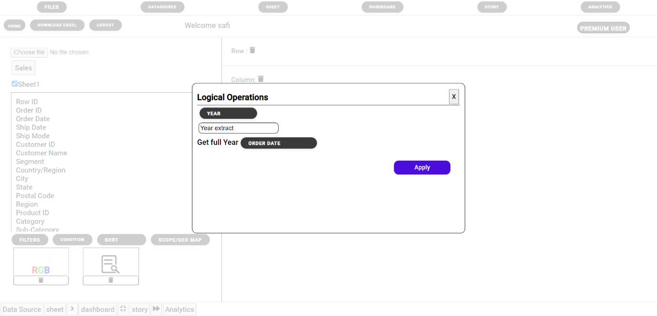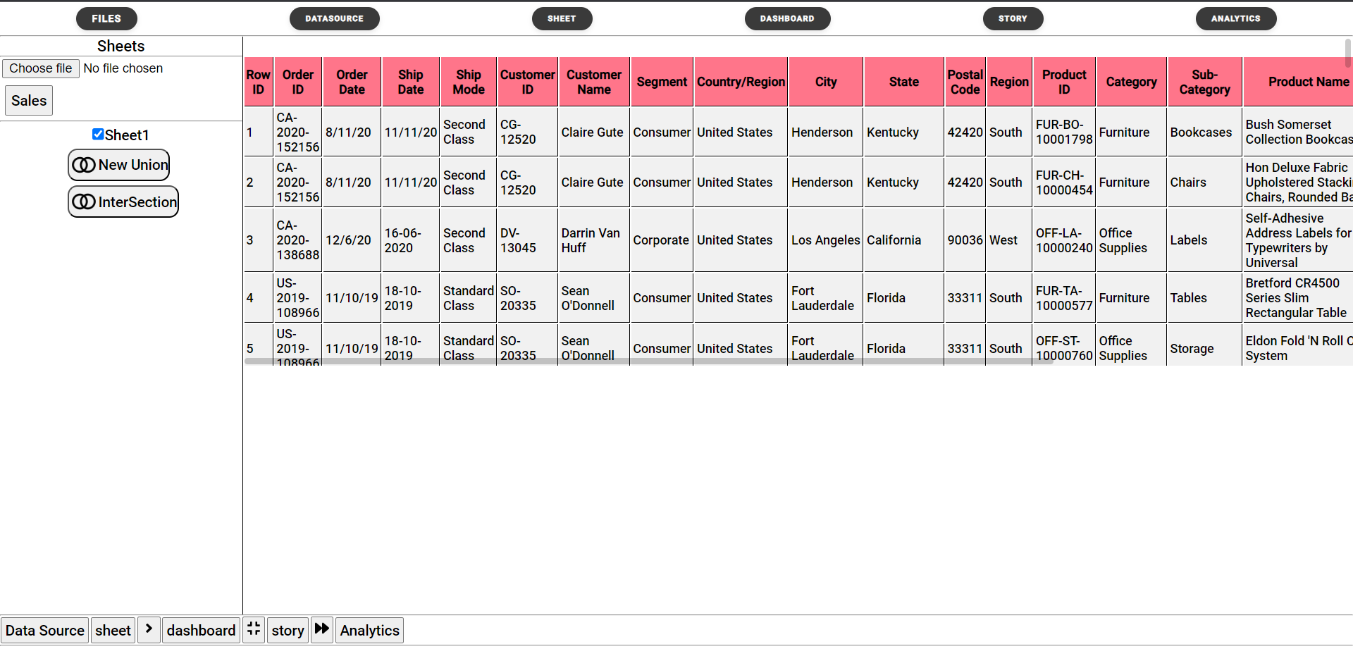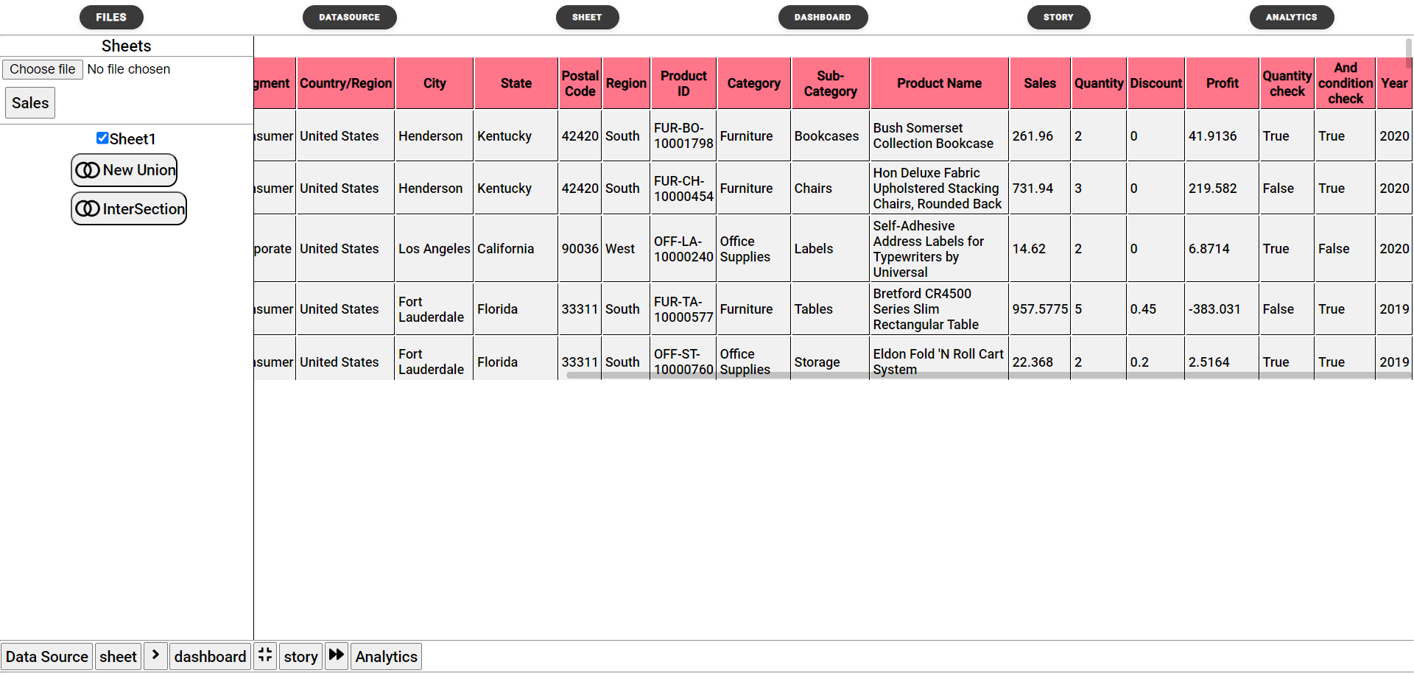
- Quarter condition: Also takes column with Dates (dd/mm/yyyy) , based on month it shows which quarter you are in. We are taking “Ship date” here.
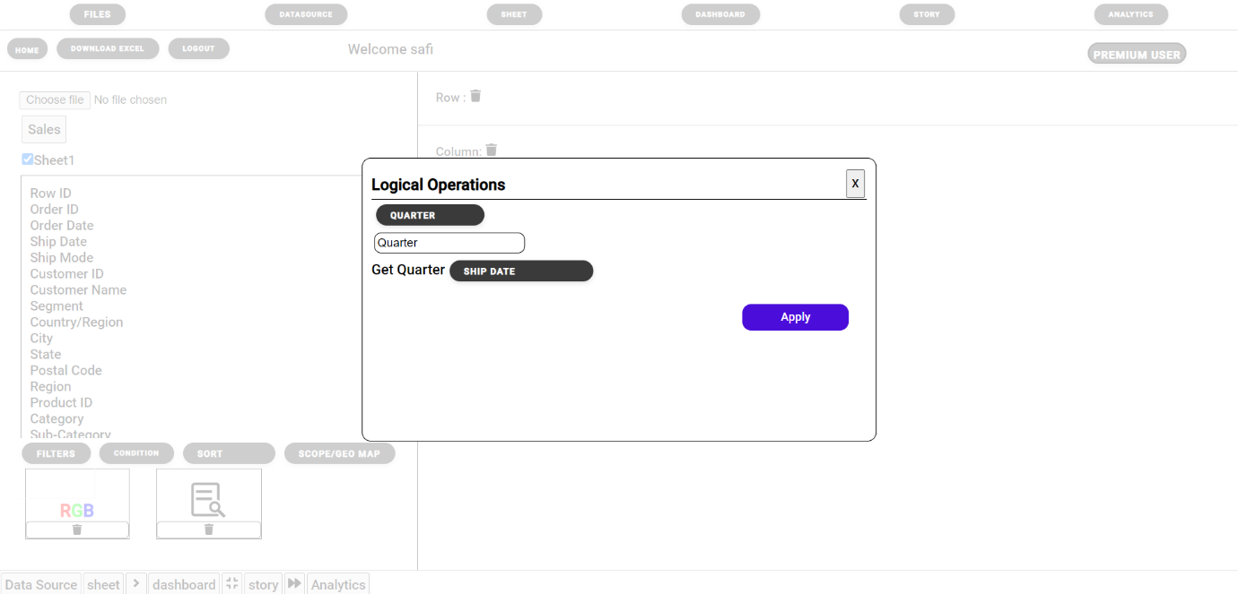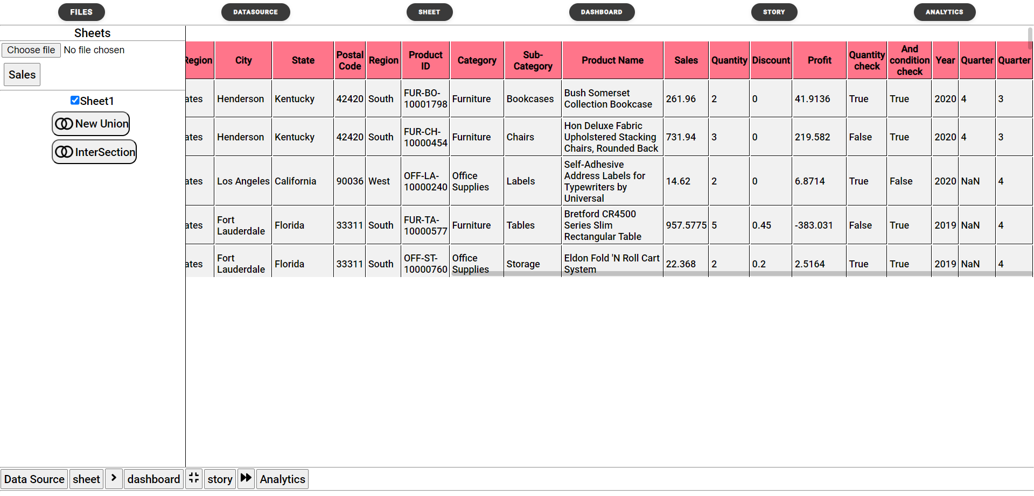

STEP 3: TABLE CALCULATION: Gives more in-depth understanding of Data.
- In this First, Drop any categorical column in ROW as well as COLUMN.
- Next Drop any numerical column beside RGD (LOD Icon) as Shown.
- Select “Cross Tab” from the graph select you should be able to see a cross table calculation.
- Delete All values from RGB,ROW and COLUMN and change graph type to GRAPH to exit cross tab.
