PROJECT OCEAN LINKS:
- PROJECT OCEAN MAIN: https://ocean-4-0-0.vercel.app/
- PROJECT OCEAN SERVER 1: https://python-api-productionserver.onrender.com/
- PROJECT OCEAN SERVER 2: https://python-api-wrh0.onrender.com/
- PROJECT OCEAN SERVER 3: https://ocean-user-serverbackend.onrender.com/
- Google Drive Link: https://drive.google.com/drive/folders/1gNwcq_c5jhYTWl98-WOvvdeBIZ7LYEaN?usp=share_link

Note: Make sure the above servers are running as shown in Project ocean testing guide 1.
STEP 1:MODEL BUILDING: PREDICTIONS USING LINEAR REGRESSION.
- Upload any CSV or excel file. (Using Superstore.csv file in this example, you can find that in the Google drive link.
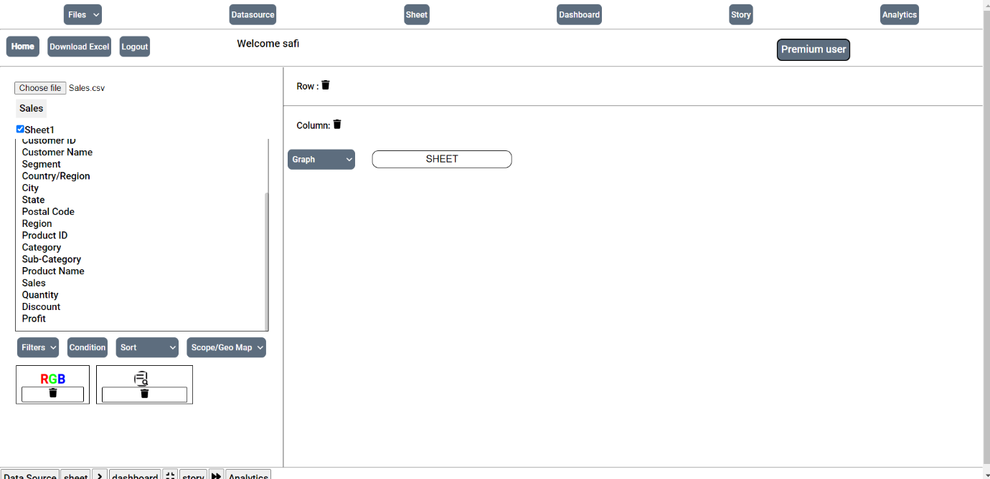
- Go to “Analytics” > “Data” > “Describe Data” you will find General meta data about the dataset. Here you can see “2 Null values”. It shows that we have empty cells in the dataset
- For Linear regression to work the dataset should be processed, cleaned and sorted.
Click on “Delete Icon” and the Null value rows will be removed from the dataset. You can check in Datasource page if the null values are deleted.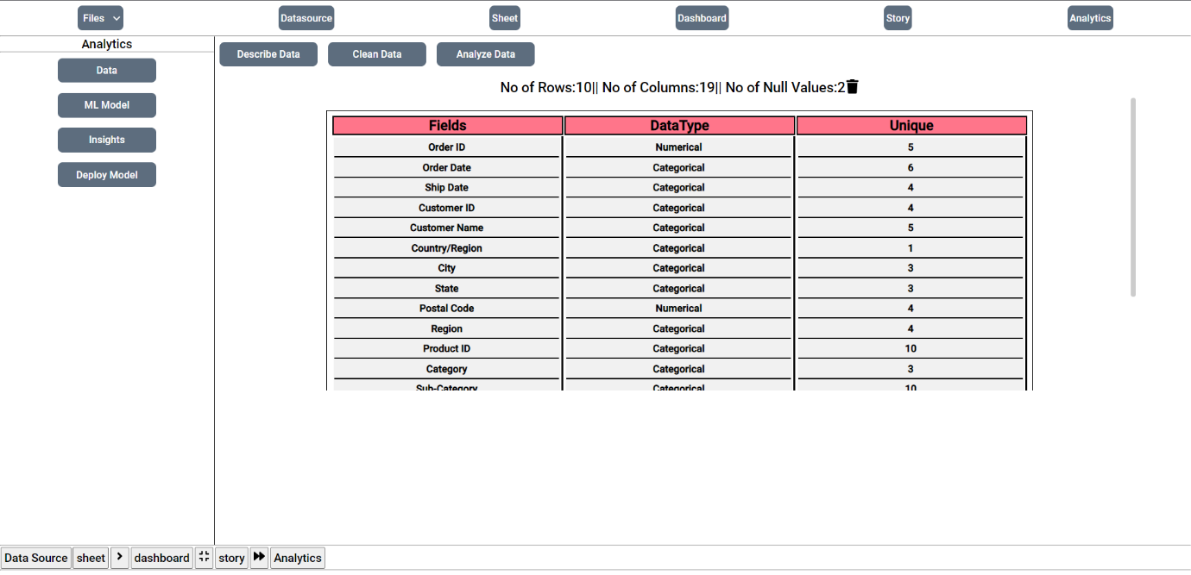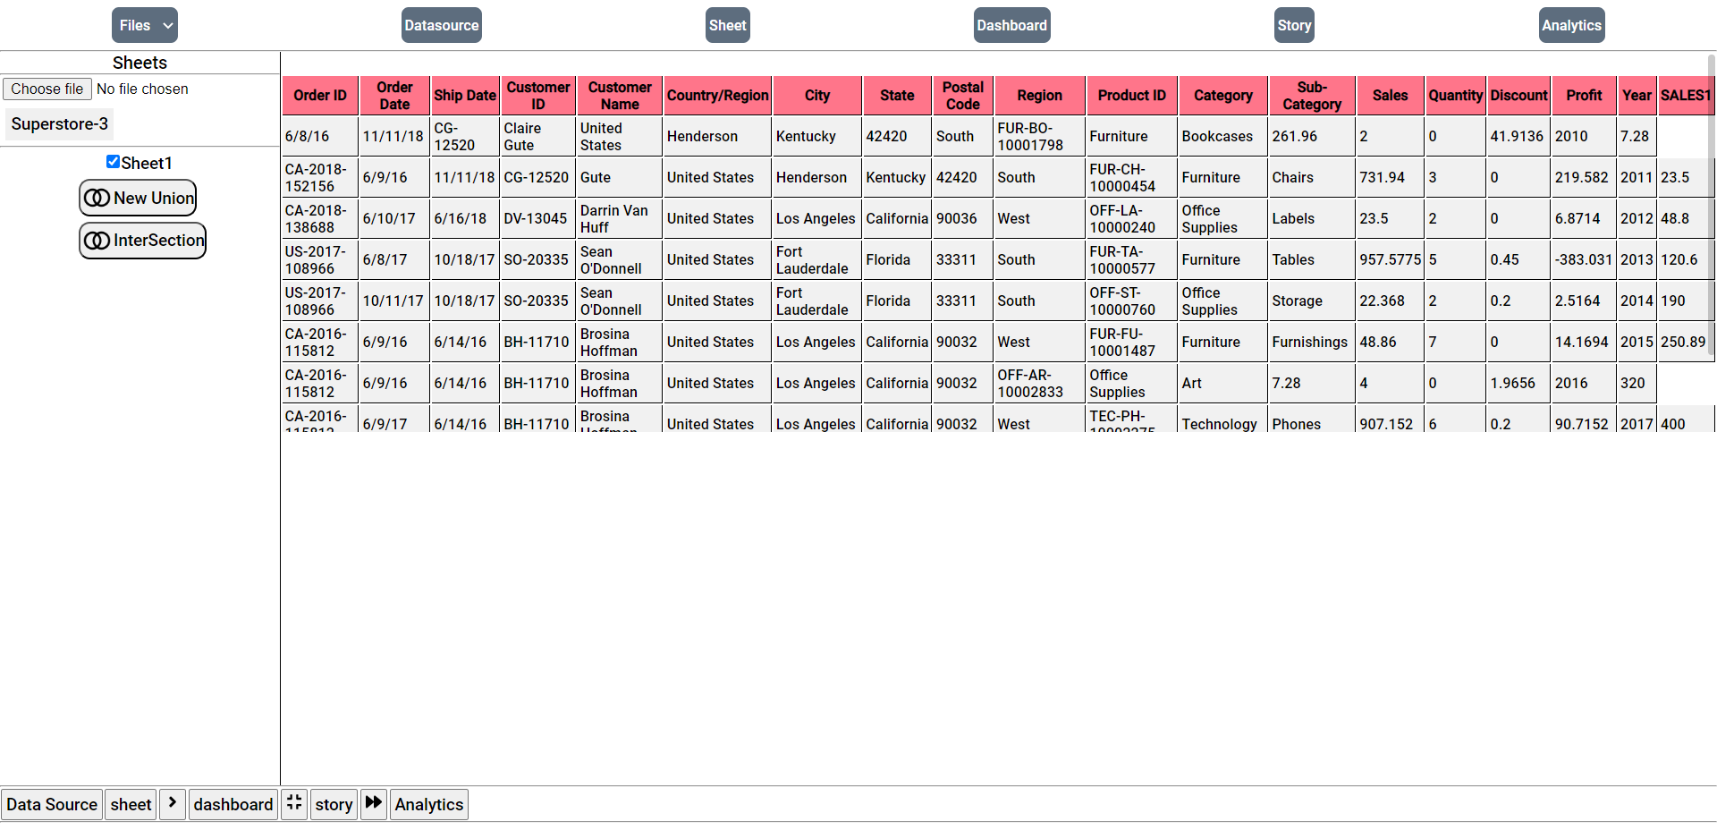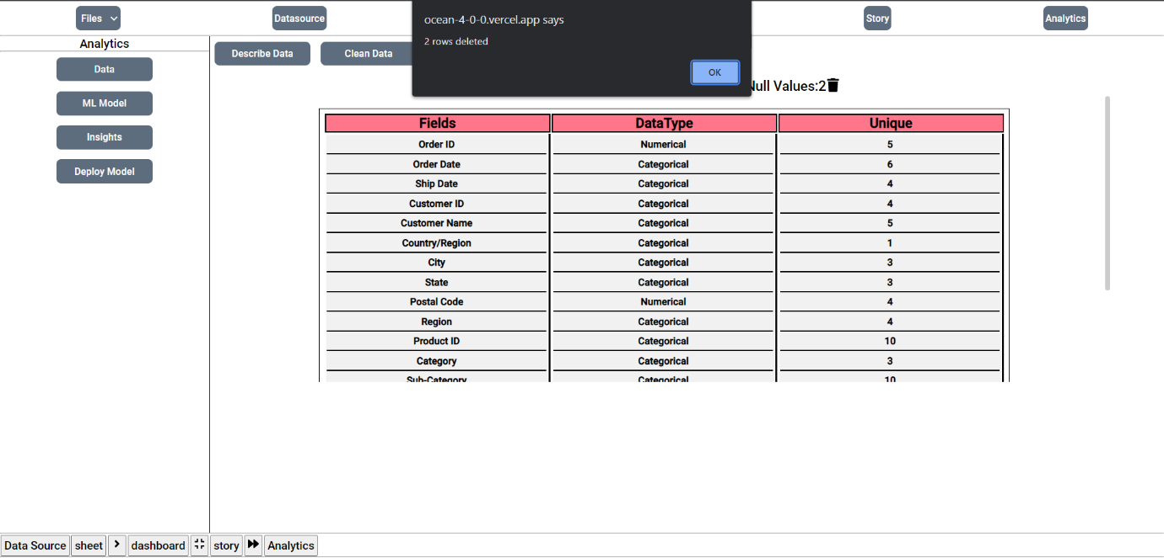

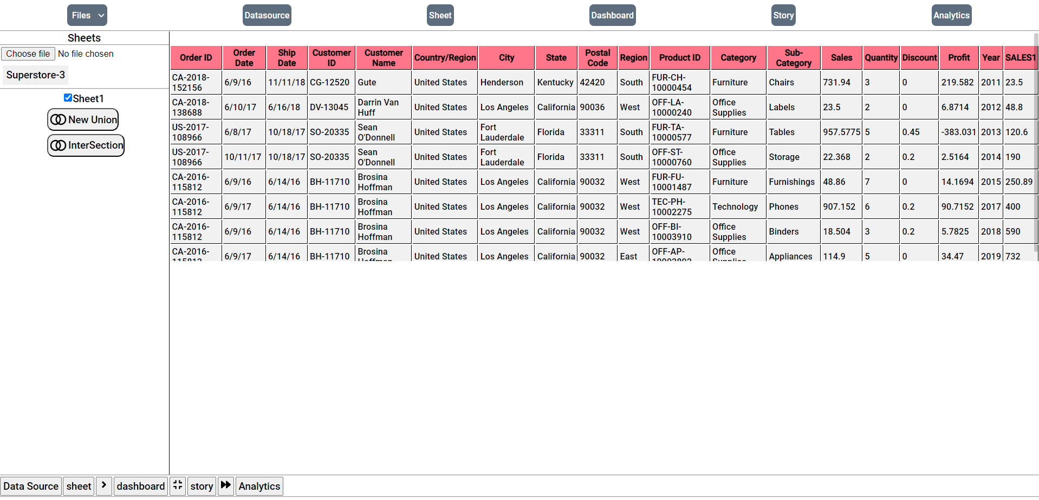
- As you can see in datasource page after deletion of null values, The data is processed, cleaned and sorted. We will be using “Year” and “SALES1” columns for predicting sales for upcoming years based on this.
(Dataset need to be Pre-processed, cleaned (Null value deletion, mean, medians for empty places one-hot decoding etc) and sorted for Linear regression to work).
- Go to to “Analytics” > ”ML model” > “Predictive Analysis” and select “Year” in Independent Variable and “SALES1” in Dependent Variable. (After selecting the Year and SALES1 from dropdown menu you may face rendering issues just click on the both the dropdown menus once the graph should be rendered Fine.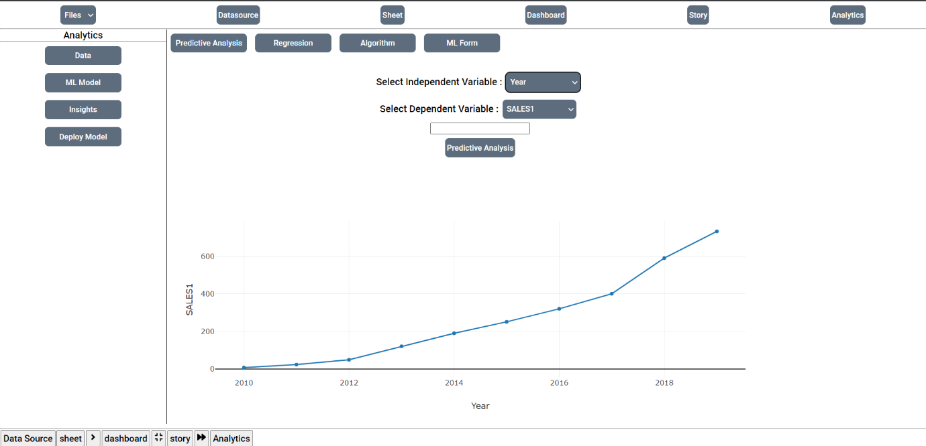
- As you can see, the cumulative sales is till 2018-2019 as shown now enter any year and the linear regression should predict the sales of that year.
Enter next year then click “Predictive analysis” then the predictive sales on that year is shown as well
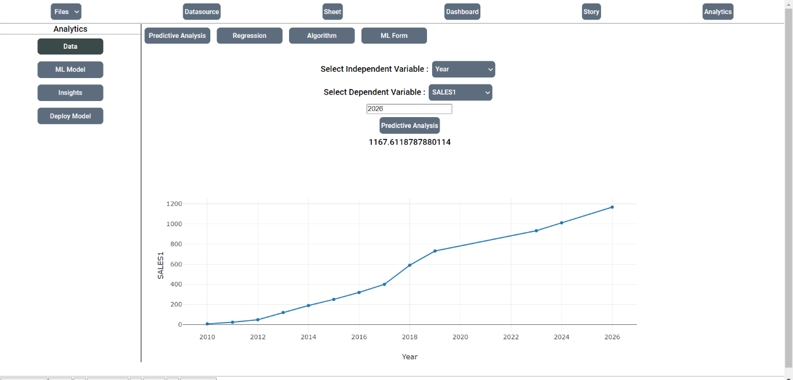
- Here you can see the sales prediction till 2026. (Years entered one after another are 2020,2023,2024,2026) this the predicted graph.

